Teacher Education Handbook

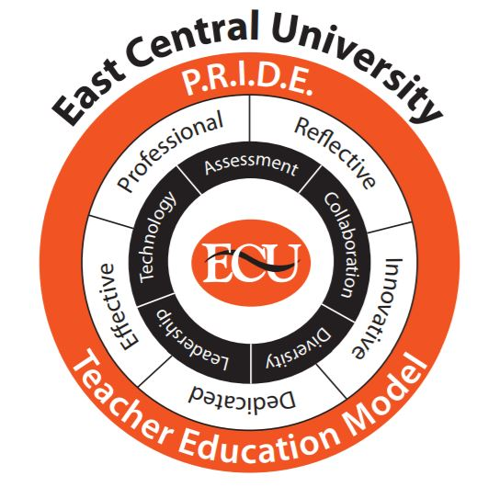

East Central University
College of Education and Psychology
Department of Education
Teacher Education Handbook
Updated: Summer 2020

Table of Contents
Contents
Purpose of the Handbook 4
CHAPTER 1: Introduction to the Teacher Education Program 5
Welcome 5
Unit Beliefs 5
Philosophy 5
Conceptual Framework 6
Council for the Accreditation of Educator Preparation (CAEP) Standards 7
Code of Ethics of the Education Profession 8
Mission Statements 10
Program Director Contact Information 11
Initial Teacher Certification Programs 11
Teacher Certification Programs of Study 12
Definitions 13
Professional Education Sequence 16
Undergraduate Student Admission Process 16
Re-Interview Process 17
Transfer Student Admission Process 17
Requirements for Retention and Graduation in Teacher Education 18
Proficiencies, Dispositions, and Professional Practice 18
Appeals, Suspension, and Dismissal 20
Admission Process—Appeal 20
Suspension from the Teacher Education Program 20
Denial of Admission or Dismissal from the Teacher Education Program 20
Teacher Education Committee 22
Professional Education Committee 22
Teacher Certification 22
Pathways to Teacher Education Certification in Oklahoma 23
CHAPTER 3: Professional Blocks & Field Experience 24
General Placement Policy 24
Field Experience Coordinator 25
Field Experiences I, II, and III General Requirements 25
Professional Block I 27
Professional Block II 27
Professional Block III 27
Application Requirements for Field Experiences 28
Background Clearance 28
Field Experience Placement Proposal 28
Liability Insurance 31
CHAPTER 4: Student Teaching 32
Student Teaching Description 32
Student Teaching Candidacy 32
Student Teaching Placement Guidelines and Restrictions 32
Application Requirements for Student Teaching Candidacy 33
Guideline for District Placement 35
Cooperating School Selection for Placement 35
Student Teaching Candidacy: Following Full Acceptance 35
Teacher Candidate Responsibilities 37
Adherence to School Calendar 37
Adherence to School District Rules and Policies 38
Meeting the Cooperating Teacher Expectations 38
Lesson Plans 39
Absentee Policy 39
Teachers College Code of Professional Behaviors and Dispositions 40
Failure to Follow Standards of Professionalism 40
Cohort Seminar 40
PPAT: Preparation for Critical Dimensions of Teaching 40
Guidelines for Supporting PPAT® Candidates 42
Strategies for Formative Support 43
Cooperating Teacher 43
Qualifications of the Cooperating Teacher 44
Cooperating Teacher Presence in the Classroom 44
Responsibilities of the Cooperating Teacher 44
The Initial Meeting of Teacher Candidate and Cooperating Teacher 47
The First Day of Class 47
Unannounced Observations by University Supervisor of Teacher Candidate 47
University Supervisor 47
Qualification of the University Supervisor 48
Responsibilities of the University Supervisor 48
Introductory First Meeting of the Teacher Candidate 49
Observations & Evaluations of Teacher Candidate Pre-Observation Conference Visit 49
Scheduled Observations 50
Post Observation Conference Visit 50
Performance Concerns & Intervention Plans for Teacher Candidate 50
Portfolio Policy 52
Prescribed Artifacts and Evaluation Timeline 52
Checklist and Rubrics for Evaluation of Standards 56
Submitting Portfolio Assignments 68
Feedback for Portfolio Assignments 68
Download a Portfolio 68

Purpose of the Handbook
The purpose of this handbook is to provide information related to the process of completing the Teacher Education Program at ECU and acquiring a traditional teacher certification in Oklahoma. The teacher candidate is responsible for reading and understanding the policies and procedures outlined in the handbook.

CHAPTER 1: Introduction to the Teacher Education Program

Welcome
Congratulations upon your interest in becoming a member of the teaching profession. In addition to being one of the largest professions, teaching may be considered basic to all other professions. In other words, other professions are made possible through the work of early childhood, elementary, middle, and high school teachers.

Becoming a successful teacher presents a greater challenge today than at any previous time in history. Students and families expect more from schools and teachers than in previous centuries. Pressures applied by students, families, and the profession itself, to find improved ways of teaching, have led to the development of new programs and instructional strategies such as inquiry based learning, simulation games, computer-assisted instruction, and diverse learning materials. Teachers are being challenged to utilize new approaches in an effort to improve learning. Furthermore, schools and teachers today are dealing with a student population, which is considered more knowledgeable than previous generations due to such factors as mass media, population mobility, shifts from rural to metropolitan areas, and globalization of society.
Those wishing to become effective teachers have the benefit of improved teacher preparation programs. For East Central University (ECU) students who are personally and professionally qualified, teaching offers a genuine challenge and an opportunity to make a major contribution to the improvement of society and to impact the lives of students forever.

Unit Beliefs
All education programs at East Central University believe the role of an excellent teacher is to:

- provide a fundamentally sound, research-based approach to teaching that directly and positively affects student learning;
- create a safe and secure learning environment where all students can learn;
- develop the potential of every student to gain an appreciation of learning;
- help every student acquire the basic skills and repertoire of thinking strategies for constructing and evaluating knowledge; and
- foster and enhance every student’s self-esteem.

The Teacher Education Program faculty members are committed to the belief that all students can learn and that they deserve the highest quality education. Faculty members strive to ensure that teacher candidates and graduates share and act upon this belief, thus meeting the needs of their students and the school systems they serve. Furthermore, the faculty believes that it is the right of every student to be taught by a highly qualified teacher. Highly qualified graduates of ECU demonstrate the knowledge, skills, and dispositions necessary to positively impact student learning.

Philosophy
The faculty of the College of Education and Psychology at East Central University believes that teacher education graduates must reflect the highest ideals of the teaching profession. Educators must possess knowledge in the traditional areas of scholarly endeavors as well as in pedagogy. The Teacher Education Program follows the philosophy that the effective teacher must be able to translate theory into practice, which includes developing and adapting education strategies to meet the needs of all diverse learners.

Conceptual Framework
[Figure 1]

The conceptual framework model developed, adopted, and implemented by the East Central University’s professional education unit is based on current research and sound professional practice (Figure 1). The PRIDE Teacher Education Model reflects the unit’s beliefs that professionals engage in reflective practices that lead to improved instruction (Robichaux & Guarino, 2012); that professionals are confident in their ability to use innovative pedagogy to create relevant lessons to engage ALL learners (Tenuto, P. 2016); that professionals inspire the belief in their students that they have value and potential; and that professionals never underestimate their contributions to a student’s success (Jimerson & Gaddock, 2015). The PRIDE conceptual framework was established to reflect the university’s mission: “…to foster a learning environment in which students, faculty, staff, and community interact to educate students for life in a rapidly changing and culturally diverse society”, as well as the philosophy of the Department of Education: “The faculty believe that teacher education graduates must reflect the highest ideals of the teaching profession. They must possess knowledge in the traditional areas of scholarly endeavors, as well as knowledge of effective pedagogy.” The unit adopted the unifying phrase “Professional, Reflective, Innovative, Dedicated, and Effective Teacher Education Model”, or its acronym PRIDE, to represent the model.

The PRIDE Teacher Education Model also incorporates underlying themes of assessment, collaboration, diversity, leadership, and technology, which are integrated throughout each program of study. These themes are identified by the Interstate Teacher Assessment and Support Consortium (InTASC), as well as the Council for the Accreditation of Educator Preparation (CAEP) as vital components of educator preparation programs. Graduates from our educator preparation program are therefore prepared to ensure that “all students are afforded the opportunity to engage in quality education as part of the social contract” (OECD, 2016). The ECU model was reviewed by stakeholders in meetings and through electronic communication during 2017 and revised to more clearly align terminology and expectations utilized in contemporary K-12 public schools.

The unifying concept “Professional, Reflective, Innovative, Dedicated, and Effective Teacher Education Model”, or its acronym PRIDE, evolved from best practices research, as well as relevant, effective, instructional practices used in the classroom (Bruner, Bloom, Gardner, Maslow, Rogers, InTASC and CAEP). ECU strives to develop proud educators who see themselves as professional change agents who have the knowledge and skills necessary to transform the lives of their students, their schools, and their communities. In order to develop this sense of teacher efficacy, ECU’s professional education programs instill reflection as an ongoing part of the teaching cycle. As mentioned in multiple studies and articles, an effective educator engages in reflection over his or her instruction and interactions (Dewey, 1933; Council for the Accreditation of Educator Preparation, 2013; Council of Chief State School Officers, 2011; Ruth, 2012). According to the Gates Foundation, reflecting on the practice of teaching, whether through videos, test scores, surveys, observations, or in discussions with others, allows for educator improvement (Gates, 2011).

ECU’s educator preparation program also encourages pre-service teachers to think divergently and to embrace innovation. According to Edwards (2014), “Our kids learn within a system of education devised for a world that increasingly does not exist”. Therefore, to be relevant in the classroom, educators must use innovative tools, challenging content, and active instruction. ECU’s teacher preparation program provides and models instructional tools that encourage creativity, problem solving, and active learning. ECU teacher graduates are prepared to teach students the hard and soft skills necessary to be competitive in today’s job market.

With the changing dynamics of the classroom makeup, it is imperative that teachers be culturally responsive and dedicated toward meeting the needs of all students. According to Bui & Fagan (2013), "Culturally responsive teaching has been defined as 'using the cultural knowledge, prior experiences, frames of reference, and performance styles of ethnically diverse students to make learning encounters more relevant and effective for them” as cited in Gay, 2000, p. 29. Teacher candidates at ECU participate in multiple field experiences to engage with diverse students in diverse school settings. Teacher candidates also prepare lessons, activities, and case studies to develop culturally responsive teaching skills. Whipp (2013) found that effective, socially-just teacher education programs prepared educators who are able to engage with students in “culturally responsive ways and also act as critical change agents in schools and society” (p. 454). ECU’s teacher candidates graduate as culturally responsive educators capable of collaborating with students, parents, guardians, administrators, and community members dedicated to meeting the needs of all students.

ECU’s educator preparation programs are built around the tenants of the PRIDE conceptual framework. Program completers are professional, reflective, innovative, and dedicated educators who positively impact students, schools, and communities. They are able to make a positive impact by utilizing the embedded knowledge and skills related to assessment, collaboration, diversity, leadership, and technology. Program completers leave ECU’s program as leaders in the education field. Teacher leaders have a tremendous influence on school-wide instruction or policy. They are increasingly recognized as tremendous levers for reform (Stein, Macaluso & Stanulis, 2016).

A cycle of continuous improvement is embedded in the Educator Preparation Program at East Central University to ensure all stakeholders that program completers have the knowledge, skills, and dispositions necessary to be effective teachers. Program completers who leave East Central University have demonstrated mastery of state and national standards, as well as program specific standards. The assessment plan built into the educator preparation program provides feedback to teacher candidates throughout the program. Prior to certification teacher candidates must complete rigorous coursework, a comprehensive performance assessment, and a program portfolio. Candidates must have positive evaluations on all field and clinical experiences. At the end of their program teacher candidate has earned the right to be called “teacher” and leave East Central University with PRIDE in their accomplishments and with their chosen profession.

Council for the Accreditation of Educator Preparation (CAEP) Standards
The standards for all Teacher Education Programs at ECU are those required by the Council for the Accreditation of Educator Preparation (CAEP) and those of the State of Oklahoma, plus institutional standards identified and implemented by the unit. CAEP standards provide the framework for both the advanced (graduate) and initial (undergraduate) certificate programs of the Teacher Education Program. Initial as well as advanced programs at ECU demonstrate candidate, or preservice teacher, mastery of the state adopted InTASC Standards as well as the specific program standards. CAEP’s standards (http://caepnet.org/standards/introduction), which apply to advanced and initial programs, are listed below:
- Standard 1. Content and Pedagogical Knowledge: the provider ensures that candidates develop a deep understanding of the critical concepts and principles of their discipline and, by completion, are able to use discipline-specific practices flexibly to advance the learning of all students toward attainment of college- and career-readiness standards.
- Standard 2. Clinical Partnerships and Practice: the provider ensures that effective partnerships and high-quality clinical practice are central to preparation so that candidates develop the knowledge, skills, and professional dispositions necessary to demonstrate positive impact on all P-12 students’ learning and development.
- Standard 3. Candidate Quality, Recruitment, and Selectivity: the provider demonstrates that the quality of candidates is a continuing and purposeful part of its responsibility from recruitment, at admission, through the progression of courses and clinical experiences, and to decisions that completers are prepared to teach effectively and are recommended for certification. The provider demonstrates that development of candidate quality is the goal of educator preparation in all phases of the program. This process is ultimately determined by a program’s meeting of Standard 4.
- Standard 4. Program Impact: the provider demonstrates the impact of its completers on P-12 student learning and development, classroom instruction, and schools, and the satisfaction of its completers with the relevance and effectiveness of their preparation.
- Standard 5. Provider Quality Assurance and Continuous Improvement: the provider maintains a quality assurance system comprised of valid data from multiple measures, including evidence of candidates’ and completers’ positive impact on P-12 student learning and development. The provider supports continuous improvement that is sustained and evidence-based, and that evaluates the effectiveness of its completers. The providers uses the results of inquiry and data collection to establish priorities, enhance program elements and capacity, and test innovations to improvement completers’ impact on P-12 student learning development.
ECU completed CAEP accreditation in the Fall of 2019 and was awarded full accreditation for undergraduate and graduate programs until June of 2027.

Code of Ethics of the Education Profession
Teacher Preparation programs at ECU have adopted the Code of Ethics of the education profession as adopted by the 1975 NEA representative assembly. At ECU students are introduced to the Code of Ethics during EDUC 2012, Diversity in American Education, principles are followed throughout the program, and student teachers complete an assessment, which measures the Code of Ethics. The Code of Ethics can be found at: http://www.nea.org/home/30442.htm as well as below.
Preamble
The National Education Association believes that the education profession consists of one education workforce serving the needs of all students and that the term ‘educator’ includes education support professionals.
The educator, believing in the worth and dignity of each human being, recognizes the supreme importance of the pursuit of truth, devotion to excellence, and the nurture of the democratic principles. Essential to these goals is the protection of freedom to learn and to teach and the guarantee of equal educational opportunity for all. The educator accepts the responsibility to adhere to the highest ethical standards.
The educator recognizes the magnitude of the responsibility inherent in the teaching process. The desire for the respect and confidence of one's colleagues, of students, of parents, and of the members of the community provides the incentive to attain and maintain the highest possible degree of ethical conduct. The Code of Ethics of the Education Profession indicates the aspiration of all educators and provides standards by which to judge conduct.
The remedies specified by the NEA and/or its affiliates for the violation of any provision of this Code shall be exclusive and no such provision shall be enforceable in any form other than the one specifically designated by the NEA or its affiliates.
Principle 1
Commitment to the Student- (as measured by InTASC Standards 1, 2, 3)
The educator strives to help each student realize his or her potential as a worthy and effective member of society. The educator therefore works to stimulate the spirit of inquiry, the acquisition of knowledge and understanding, and the thoughtful formulation of worthy goals.
In fulfillment of the obligation to the student, the educator--
- Shall not unreasonably restrain the student from independent action in the pursuit of learning.
- Shall not unreasonably deny the student's access to varying points of view.
- Shall not deliberately suppress or distort subject matter relevant to the student's progress.
- Shall make reasonable effort to protect the student from conditions harmful to learning or to health and safety.
- Shall not intentionally expose the student to embarrassment or disparagement.
- Shall not on the basis of race, color, creed, sex, national origin, marital status, political or religious beliefs, family, social or cultural background, or sexual orientation, unfairly—
  - Exclude any student from participation in any program
  - Deny benefits to any student
  - Grant any advantage to any student
- Shall not use professional relationships with students for private advantage.
- Shall not disclose information about students obtained in the course of professional service unless disclosure serves a compelling professional purpose or is required by law.

Principle II
Commitment to the Profession- (as measured by InTASC Standards 9 and 10)
The education profession is vested by the public with a trust and responsibility requiring the highest ideals of professional service.
In the belief that the quality of the services of the education profession directly influences the nation and its citizens, the educator shall exert every effort to raise professional standards, to promote a climate that encourages the exercise of professional judgment, to achieve conditions that attract persons worthy of the trust to careers in education, and to assist in preventing the practice of the profession by unqualified persons.
In fulfillment of the obligation to the profession, the educator--
- Shall not in an application for a professional position deliberately make a false statement or fail to disclose a material fact related to competency and qualifications.
- Shall not misrepresent his/her professional qualifications.
- Shall not assist any entry into the profession of a person known to be unqualified in respect to character, education, or other relevant attribute.
- Shall not knowingly make a false statement concerning the qualifications of a candidate for a professional position.
- Shall not assist a non-educator in the unauthorized practice of teaching.
- Shall not disclose information about colleagues obtained in the course of professional service unless disclosure serves a compelling professional purpose or is required by law.
- Shall not knowingly make false or malicious statements about a colleague.
- Shall not accept any gratuity, gift, or favor that might impair or appear to influence professional decisions or action.

Mission Statements
In order to define the goals, ethics, and culture of ECU’s Teacher Education Programs, the following mission statements are used to guide decisions and the direction of the programs.

University
We Educate and Empower Students to Understand and Transform Our World.

College of Education and Psychology
The College of Education and Psychology’s mission is to provide quality programs that prepare students to enter careers in the fields of Education, Psychology, Health, and Kinesiology. Academic preparation requires traditional general studies, professional studies, and specialty coursework.
Department of Education: Early Childhood Education
The mission of the Early Childhood Education Program is to provide a quality educational program that prepares students to enter careers as pre-kindergarten through third grade teachers and to provide leadership in other child education and child care settings.

Department of Education: Elementary Education
The mission of the Elementary Education Program is to provide a quality educational experience that prepares candidates to be successful teachers in first through eighth grades.

Department of Art
The Bachelors of Fine Arts degree program prepares students to produce art at a professional level, as well as engage in art criticism, participate in exhibitions, undertake commissions, support a client’s goals and teach art. Ancillary to that mission, the Art Department prepares students for graduate study in the Arts and related fields.

Department of English and Languages
The mission of the Department of English and Languages is to prepare students for employment as teachers, writers, editors, or for liberal-arts positions in business and industry. The department also seeks to prepare students who are interested in continuing their education for graduate programs in English, Comparative Literature, Composition and Rhetoric, Humanities, Film Studies, and Cultural Studies.

Department of Music: Music Education
We believe in the Department of Music that we have a unique role to play in Oklahoma music. Accordingly, the faculty have adopted the following:
- To educate students for lives of service and contribution as teachers, performers, composers and scholars;
- To provide and nurture a nucleus of musical life for the community;
- To educate the university student population regarding music's intrinsic value as a part of the human experience and its central role in human culture; and
- To mutually encourage one another in professional growth and attainment.
As an integral part of our mission, we commit ourselves to continuing steps toward realizing the full potential of community, both as teachers and as colleagues; further, we commit to interaction with our students that emphasizes personal attention and interest in their total musical/intellectual development.
Finally, the faculty affirm the university's mission of “educating and empowering students to understand and transform our world” in all aspects of our work.

Program Director Contact Information
Dean, College of Education and Psychology  Phyllis Isaacs  580-559-5350  bsherbrn@ecok.edu  Lanoy Education, 204 D  Department of Education Chair  Shelli Sharber, Ph.D.  580-559-5240  ssharber@ecok.edu  Lanoy Education, 204 C  Coordinator of Field Experience & Student Teaching  Joshua Vaughn  580-559-5349  josjvau@ecok.edu  Lanoy Education, 204  Director of Early Childhood Ed.  Melonie Johnson, M.Ed.  580-559-5928  meldjoh1@ecok.edu  Lanoy Education, 215 A  Director of Elementary Ed.  Jenn Snell, M.Ed.  580-559-5579  jenlsne@ecok.edu  Lanoy Education, 203 D  Director of P-12 Art Ed.  Brad Jessop, Ph.D.  580-559-5353  bjessop@ecok.edu  Hallie Brown Ford, 134 | Director of P-12 Music Ed. - Instrumental  Nicholaus Meyers, DMA  580-559-5390  nmeyers@ecok.edu  HBFFAC, 149  Director of P-12 Music Ed. - Vocal  Kelby Pletcher, M.Ed.  580-559-5332  kpletcher@ecok.edu  Faust, 121  Director of Secondary Mathematics Ed.  Mary Harper, Ph.D.  580-559-5286  mharper@ecok.edu  Science Hall, 202 A  Director of Secondary History Ed.  Scott Barton, Ph.D.  580-559-5563  sbarton@ecok.edu  Horace Mann, 318 B  Director of Secondary Science Ed.  Carl Gilbert, Ph.D.  580-559-5549  cgilbert@ecok.edu  Physical and Environmental Science Building, 101 A  Director of English Ed.  Jennifer Dorsey, Ph.D.  580-559-5439  jdorsey@ecok.edu  Horace Mann, 335 A

Initial Teacher Certification Programs
Based on its accreditation and program approvals granted by the Office of Educational Quality and Accountability, ECU is authorized to recommend candidates for certification in the following areas to the Oklahoma State Department of Education (OSDE).

CERTIFICATE AREA | GRADE LEVEL | CERTIFICATION TESTS REQUIRED
Art | PK-12 | OGET, OSAT(02), PPAT
Early Childhood | PK-3 | OGET, OSAT(05), ORT, PPAT
Elementary | 1-8 | OGET, OSAT(2 subtests) ORT, PPAT  Subtest 1: Reading/Language Arts(50)  Subtest 2: Math/Sci/SS/Health & Fitness/Fine Arts(51)
English | 6-12 | OGET, OSAT(07), PPAT
History/Social Studies
US History/OK History  Government/Economics | 6-12 | OGET, OSAT(17), PPAT
World History/ Geography | 6-12 | OGET, OSAT(18), PPAT
Mathematics
Intermediate Mathematics | 6-12 | OGET, OSAT(25), PPAT
Advanced Mathematics | 6-12 | OGET, OSAT(11), PPAT
Music
Instrumental/General Music | PK-12 | OGET, OSAT(01), PPAT
Vocal/General Music | PK-12 | OGET, OSAT(03), PPAT
Science
Biological Science | 6-12 | OGET, OSAT(10), PPAT
Chemistry | 6-12 | OGET, OSAT(04), PPAT
Physical Science | 6-12 | OGET, OSAT(13), PPAT
Earth Science | 6-12 | OGET, OSAT(08), PPAT
Physics | 6-12 | OGET, OSAT(14), PPAT

Teacher Certification Programs of Study
East Central University’s Department of Education offers professional preparation leading to teacher certification. The following links provide both the suggested 4-year degree plan as well as the degree checklist for each program:

Year | Catalog Majors and General Education Requirements
2019-2020 | https://www.ecok.edu/sites/default/files/website_files/Academics/ECU_Catalog_19-20_Bookmarks%204.16.2020.pdf
2018-2019 | https://www.ecok.edu/sites/default/files/website_files/Academics/Academic_Affairs/ECU_Catalog_18-19_(8-15-18).pdf
2017-2018 | https://www.ecok.edu/sites/default/files/website_files/Academics/Academic_Affairs/Catalog_17-18.pdf
2016-2017 | https://www.ecok.edu/academic-affairs-programs/academics/degree-requirements/2008-2009
2015-2016 | https://www.ecok.edu/academic-affairs-programs/academics/2015-2016-catalog-majors-and-general-education-requirements
*The Catalog Year will match a student enters the university as long as he or she attends school consecutively.
**For more Catalog Years, visit: https://www.ecok.edu/academics/catalog

Interstate Teacher Assessment and Support Consortium (InTASC)
The Oklahoma Office of Educational Quality and Accountability has adopted the Interstate Teacher Assessment and Support Consortium (InTASC) as the standards for Oklahoma educator preparation programs. The InTASC sets forth the expectations of effective teachers through the following ten standards. These standards were developed in April of 2011. The InTASC standards, which each Teacher Education Program candidate must demonstrate mastery of, are as follows:
- Standard #1: Learner Development: The teacher understands how learners grow and develop, recognizing that patterns of learning and development vary individually within and across the cognitive, linguistic, social, emotional, and physical areas, and designs and implements developmentally appropriate and challenging learning experiences.
- Standard #2: Learning Differences: The teacher uses understanding of individual differences and diverse cultures and communities to ensure inclusive learning environments that enable each learner to meet high standards.
- Standard #3: Learning Environments: The teacher works with others to create environments that support individual and collaborative learning, and that encourage positive social interaction, active engagement in learning, and self-motivation.
- Standard #4: Content Knowledge: The teacher understands the central concepts, tools of inquiry, and structures of the discipline(s) he or she teaches and creates learning experiences that make these aspects of the discipline accessible and meaningful for learners to assure mastery of the content.
- Standard #5: Application of Content: The teacher understands how to connect concepts and use differing perspectives to engage learners in critical thinking, creativity, and collaborative problem solving related to authentic local and global issues.
- Standard #6: Assessment: The teacher understands and uses multiple methods of assessment to engage learners in their own growth, to monitor learner progress, and to guide the teacher’s and learner’s decision making.
- Standard #7: Planning for Instruction: The teacher plans instruction that supports every student in meeting rigorous learning goals by drawing upon knowledge of content areas, curriculum, cross-disciplinary skills, and pedagogy, as well as knowledge of learners and the community context.
- Standard #8: Instructional Strategies: The teacher understands and uses a variety of instructional strategies to encourage learners to develop deep understanding of content areas and their connections, and to build skills to apply knowledge in meaningful ways.
- Standard #9: Professional Learning and Ethical Practice: The teacher engages in ongoing professional learning and uses evidence to continually evaluate his/her practice, particularly the effects of his/her choices and actions on others (learners, families, other professionals, and the community), and adapts practice to meet the needs of each learner.
- Standard #10: Leadership and Collaboration: The teacher seeks appropriate leadership roles and opportunities to take responsibility for student learning, to collaborate with learners, families, colleagues, other school professionals, and community members to ensure learner growth, and to advance the profession.
For more information about the InTASC Model Core Teaching Standards, please visit: https://www.ets.org/ppa/test-takers/teachers/build-submit/requirements/.

Definitions
In order to function as a cohesive unit, terminology must be defined for all participants. The following are terms used throughout the Teacher Education Program at ECU:
- Candidate: A candidate, sometimes referred to as a teacher candidate, is a student who is enrolled in Teacher Education courses. These students are normally completing their sophomore, junior, or senior year.
- Completer: A completer is a student who has completed the program and graduated from ECU.
- Cooperating Teacher: A cooperating teacher is a mentor teacher in a local school who is overseeing the field experience or student teaching experience of a candidate. A cooperating teacher is vital to the growth of a candidate and is a necessary partner to the Department of Education.
- Mentor Teacher: A mentor teacher is sometimes used to refer to a cooperating teacher who hosts a Block I, II, or III candidate in his or her classroom.
- OGET: The Oklahoma General Education Test (OGET) must be passed by candidates seeking entrance into the teacher education program. A passing score of 240 on the OGET is also required to become a certified teacher in Oklahoma.
- OSAT: The Oklahoma Subject Area Test (OSAT) must be passed with at least a 240 by candidates seeking teacher education certification in Oklahoma.
- PPAT: The Praxis Performance Assessment for Teachers (PPAT) is the third and final certification exam required for certification as a teacher in Oklahoma.
- University Supervisor: A university supervisor is an instructor or professor from ECU. He or she is knowledgeable in the process of student teaching and is viewed as a partner with the cooperating teacher and student teacher during the student teaching semester.

Tiger PRIDE Notes

- I am struggling to decide what grade level or content area I want to teach. Who can I talk to about my decision to become a teacher? Being a teacher is one of the most profound and life-changing careers a person can have. However, the decision to follow your heart is not always an easy decision. When deciding what grade level, content area, or location you are wanting to teach, discuss your options with any (and maybe all) of the following individuals: friends/colleagues, parents/guardians, extended family, former teachers, current instructors, mentor/cooperating teachers, advisees, and your program director.
- If I am having issues with an instructor, advisor, or mentor/cooperating teacher, with whom can I discuss this issue? If you have an issue, discuss it with the following people in this order:
  - The instructor, advisor, coordinator of Field Experiences (if an issue in field experience), or mentor/cooperating teacher that there is an issue with and try to determine a solution.
  - Email or meet with your advisor to discuss the issue.
  - Email or meet with your program director to discuss the issue.
  - Once all of the attempts have been made and there is still no change, you may set up a meeting with the Department Chair.
  - If suggestions from the program director and/or department chair do not work, schedule a meeting with the Dean of Education and Psychology.
  - Note: Complaining about the issue to friends, classmates, other instructors, or friends on social media or face-to-face is not part of the chain of communication for effectively resolving issues and could result in an Anecdotal Note or Disposition Concern.
- Why do I have to complete a portfolio during the Professional Education Block Sequence? As a requirement students are required to demonstrate mastery of the InTASC standards. In order for the College of Education and Psychology to continue to gather growth data, each teacher candidate must master the knowledge, skills, and attitudes/dispositions necessary through the completion of the portfolio to become an effective teacher.
- When I graduate with my bachelor’s degree, will I be a certified teacher? As long as you have successfully completed the certification exams (OGET, OSAT, and PPAT), completed a background check, and successfully completed your bachelor’s degree with a 2.75 GPA or higher, you can apply to the state of Oklahoma for a teacher’s certification upon competition of your bachelor’s degree.

CHAPTER 2: Teacher Education General Information

Professional Education Sequence
All teacher education students are required to complete the professional education sequence as part of their teacher education program. The following is the required course sequence for teacher candidates and is a guide for successful completion of their program. The blocks are sequential and there are prerequisites to some of the courses in the professional education sequence. The prerequisites are listed in the University Catalog.
OPEN – Taken after General Psychology
(normally completed before acceptance into Teacher Education)
PSYCH 3463 Child and Adolescent Psychology (prerequisite for EDPSY 3515)
EDUC 2402 Survey of Exceptional Child

BLOCK I– Sophomore Year (4 Hours)
EDUC 2012 Diversity in American Education
EDUC 2631 Foundations of Education Technology
EDUC 2211 Field Experience 1

BLOCK II – Junior Year (4 Hours)
EDPSY 3513 Educational Psychology
EDUC 3001 Field Experience II

BLOCK III – First Semester Senior Year (5 Hours)
EDUC 4042 Strategies for Effective Teaching
EDUC 4632 Educational Technology Integration Strategies
EDUC 4611 Field Experience III

BLOCK IV – Last Semester Senior Year (12 Hours)
EDUC 4262 Student Teaching Seminar I- focus PPAT
EDUC 4282 Student Teaching Seminar II- focus Classroom Management
EDUC 4954 Supervised Student Teaching Elementary Schools*
EDUC 4964 Supervised Student Teaching Grades PK-12*
EDUC 4974 Supervised Student Teaching Secondary Schools*
*Depends on a student’s program of study. Students are required to enrolled in the appropriate section twice.

Undergraduate Student Admission Process
Students, who are considering teacher education as a career, usually take Block I courses their sophomore year. Application for selection and admission to the Teacher Education Program will be made while students are enrolled in Block I.

Applications for Teacher Education are considered in light of the student’s disposition for the teaching profession, work in Block I, college grade point average, English Composition grades, Oklahoma General Education Test (OGET), grade in Fundamentals of Human Communication, personnel records, and other pertinent data. An interview, which includes an evaluation of ethics, is held with the student by a team of education faculty. After full consideration, the applicant is either admitted to the teacher education program or referred for a second interview. After a second interview if an applicant is denied, a student can appeal to the Teacher Education Committee (see section titled, “Appeals, Suspension, and Dismissal”).

A student must meet the following criteria to be selected for the Teacher Education Program:
- Submit a completed “Application for Selection/Admission Into Teacher Education” form which can be found at the following link: https://forms.gle/Nt7AH2PsS6rx2c6C9
- After completion of at least 36 credit hours with a grade point of 2.75 or better, the student may enroll in EDUC 2012 Diversity in American Education.
- Achieve a “C” or above in ENG 1113 Freshman Composition I, ENG 1213 Freshman Composition II, and COMM 1113 Fundamentals of Human Communication. The student can be currently enrolled in these courses but may not progress to professional block II without achieving a “C” or better upon completion of each course.
- Receive a satisfactory recommendation from an education faculty interview committee.
- Provide documentation of experiences working with children/youth (completion of EDUC 2211 Field I or concurrent enrollment will satisfy this state requirement) as required by the state.
- Provide a clear background check that does not contain a felony conviction. To submit an application for a Background Check, please visit this website, www.castlebranch.com (university code- EB65), or visit your Field Experience Blackboard shell. For more information regarding felony convictions, please go to Oklahoma State Department of Education Background Check Office. For more information about the state requirement for Background Checks for education majors, please visit: http://sde.ok.gov/sde/faqs/fingerprintbackground-checks-information.
- Admission types:
  - For Conditional Admission, numbers 1 through 6 must be fully met.
  - For Unconditional Admission, in addition to conditional admission requirements (numbers 1 through 6), achieve a passing score at the level required by the Office of Educational Quality and Accountability (OEQA) for state certification on the Oklahoma General Education Test (OGET).
After full consideration, the applicant is (a) admitted to teacher education- unconditional admission; (b) admitted on conditional admission; or (c) not admitted. Applicants who are not admitted may submit written appeal to the Teacher Education Committee for a hearing and reconsideration. Appeal procedures are available at the following link: https://www.ecok.edu/administration/academic-affairs/academic-affairs-programs/academics/colleges-schools/college-education-and-psychology/department-education/education-program-admission/appeal-dismissal-suspension.

Re-Interview Process
Teacher education applicants who receive the response of “not admitted” based on their first interview will be re-interviewed by an individual or individuals selected by the Coordinator of Field Placement. The applicant will be contacted by the Coordinator of Field Placement prior to the conclusion of Finals Week to set up a second interview.

Transfer Student Admission Process
Transfer students who have been admitted to a teacher education program at a sister institution must provide the Coordinator of Field Placement with his/her letter of acceptance and OGET scores. After having been admitted to the university, transfer students who have completed some professional education at another institution report to the Office of the Dean of the College of Education and Psychology. In the Dean’s Office, these transfer students (1) complete the “Application for Teacher Education”, (2) have their college transcripts reviewed for sufficient GPA, and (3) have their completed coursework reviewed by the Coordinator of Field Experiences. Such transfer students are not permitted to enroll in, or continue in, the professional education sequence or education methods courses until they have satisfactorily completed admission requirements.

Transfer students who have not begun a teacher education program (professional education sequence) at another institution, begin the admission process with other non-transfer students in the Block I semester.

Field Experience and Student Teaching
Teacher candidates at ECU have the opportunity to work directly with PK-12 students during three field experiences and Student Teaching in different school districts; therefore, candidates are given opportunities to experience and adapt to a variety of settings, teaching styles, grade levels, and diverse urban and rural student populations. The teacher candidates receive direct instruction, formal evaluation, and feedback throughout the experiences. The integration of theory and practice, which is evaluated through an electronic portfolio, is stressed throughout Field Experience I, II, III, and Student Teaching. All together, candidates participate in 75 Field Experience hours and 480 Student Teaching hours.

Requirements for Retention and Graduation in Teacher Education
Students who are admitted to the Teacher Education Program and intend to graduate from the program must maintain their eligibility while enrolled. The Teacher Education Program has an ongoing informal evaluation, and specified reviews of teacher education majors regarding continued eligibility for retention, certification, and graduation in teacher education. The following is the review procedure for retention:
- A continuous informal evaluation is in progress for each student enrolled in professional education classes. This evaluation is accomplished by each professor being sensitive to special problems or concerns that may be noted. If a problem or concern is observed and is considered serious enough to be a part of the student’s record, the professor will file a formal report, or Dispositional Concern, with the Chair of the Department of Education. This report will be the basis for a formal reevaluation of the student by an appropriate committee to determine the eligibility and suitability of the student to remain in teacher education.
- The second review in the retention program takes place as needed at the request of the Dean of the College of Education and Psychology and consists of the following three parts: (a) the student’s grade point average will be examined, (b) a formal evaluation by the professor, and (c) the student’s portfolio will be evaluated. A student who has not maintained an overall grade point average of 2.75 or better in all college work attempted may not enroll in additional professional education courses until the grade point average is 2.75 or better. An unfavorable evaluation by the professor will lead to a formal reevaluation of the student by an appropriate committee to determine the eligibility and suitability of the student to remain in teacher education. A student with an unsatisfactory portfolio will not be allowed to continue in the program until a satisfactory portfolio is presented.
- The third review in the retention process occurs at the time the student applies for student teaching when eligibility for student teaching will be examined.
- The evaluation process continues through EDUC 4262 Student Teaching Seminar I, EDUC 4282 Student Teaching Seminar II, and Supervised Student Teaching [EDUC 4954*, EDUC 4964*, or EDUC 4974*]. *Enrollment determined by program of study.
- Throughout the program of study, students may be required to receive a C or better in major area program coursework. If a D or below is received, a student will be required to retake the course. Students should check with their advisor regarding their program’s requirements.

Proficiencies, Dispositions, and Professional Practice
Candidates preparing for a career as a professional educator must develop and demonstrate the professional dispositions appropriate of a professional educator. ECU’s College of Education and Psychology has identified dispositions related to the following five main areas which will be addressed throughout the program:
- Professionalism: the candidate attends experience in a timely manner, dresses and acts in a professional manner, and shows the ability to use appropriate decision making skills.
- Learning: the candidate displays knowledge of subject matter and lesson planning as well as displaying a willingness to use feedback and/or criticism as an opportunity for growth and improvement.
- Respect: the candidate shows the ability to be able to work well with a variety of personalities and cultures of students and other public school professionals.
- Expectations: the candidate prepares lessons that require higher level thinking, models problem solving strategies during instruction and models professional behaviors of an educator.
- Efficacy: the candidate is committed to a belief in ongoing assessment to determine needs of students and demonstrates a positive attitude towards believing that all students can learn.
Teacher candidates are expected to have the required proficiencies and to demonstrate the dispositions and professional practice appropriate for the field of teacher education. Expectations are set forth at ECU through the use of a rubric. To see the ECU Disposition rubric used in Blocks I and IV, please visit the following link:
https://docs.google.com/document/d/1QDVO3MzgeVKz6KaoX43xX5_yONPpzH8IqtoskYrGdxo/edit?usp=sharing.

Disposition Rubric and Evaluation
The Dispositions Evaluation is completed 5 times during a candidate’s times at ECU. The Block I instructor completes a Disposition Evaluation at the competition of Foundations and then a Cooperating Teacher and University Supervisor complete the form twice during a candidate’s student teaching semester. The form used for all five of these evaluations can be found here: https://goo.gl/forms/xBmRbSHIkcL5r93x2.
This assessment is completed during the Foundations of Education and during the Student Teaching semester by Cooperating Teachers, Student Teacher, and University Supervisor. Assessment modified Spring 2017 and first used Fall 2017 embedded in Student Teaching Evaluation.

Disposition Rubric
https://drive.google.com/file/d/0B0D-tzaN2yrHVDJpejhkN180R28/view?usp=sharing

Assessment (PDF)
https://drive.google.com/file/d/0B0D-tzaN2yrHUjhZNXdXdzZGRmc/view

Link to Complete Assessment
https://docs.google.com/forms/d/e/1FAIpQLSevEm1U6Th2ncq2-p-iZMixmCqZRXVKjx7oaDYn8bhmfY6dLA/viewform

Link to Data Collected https://docs.google.com/spreadsheets/d/17jjdDnWxVhTBFfVDeua3Dwh4l2V6WtDKUh9IXhpZEM4/edit?usp=sharing

Disposition Concern
If at any time during the course of a candidate’s program, a candidate exhibits behaviors and dispositions undesirable of a future educator, then a Dispositional Concern may be filled out and turned into the Chair of the Department of Education. This assessment is completed at any time during a student’s enrollment at ECU by anyone who has a concern about a student majoring in Education. The assessment was modified Spring 2017 and first used in Spring 2017.

Assessment (PDF)
https://drive.google.com/file/d/0B0D-tzaN2yrHekRMdXhVQXZfN3M/view

Link to Complete Assessment
https://goo.gl/forms/Yb1U2f8o2iFJ6UYB2

Felony Charges
In addition, a candidate may not be certified if a felony charge or conviction appears on a background check. Also, a student will not be allowed to enter the Teacher Education Program or any field placement if a felony charge or conviction appears on a background check. Varying background checks are completed any time a student is enrolled in a course that requires hours completed in the field. ECU’s Teacher Education Programs follow the state guidelines regarding certification of convicted felons.

Appeals, Suspension, and Dismissal

Admission Process—Appeal
A candidate who is denied admission to or dismissed from the Teacher Education Program who wishes to appeal this decision must request, in writing, to the chair of the Teacher Education Committee, the Dean of Education and Psychology, a hearing within ten (10) calendar days of receipt of written notice of the proposed action. The student will be afforded those rights available under an administrative hearing. A hearing date will be set, and the student will be notified of the date, time, and location of the hearing by the chair of the committee. The Teacher Education Committee has the responsibility for conducting due process hearings for students who wish to appeal a decision or policy regarding teacher education. The chair of the committee shall render in writing, the findings of facts and the decision. This written decision will be completed within a reasonable period of time. The Dean of the College of Education and Psychology will decide if the student will be allowed to attend classes, including field experiences and student teaching, during the pendency of the hearing. Additional information concerning the process for appealing may be obtained from the office of the Dean of the College of Education and Psychology.

Suspension from the Teacher Education Program
A candidate shall be suspended immediately when there is reasonable belief that grounds exist for such suspension from the Teacher Education Program. In addition, if there is a reasonable belief, the immediate suspension of a candidate is necessary because it is to be considered in the best interests of the Teacher Education Program, the public schools, or public school students, then the Dean of the College of Education and Psychology, or in the absence of the Dean, the Chair of the Department of Education or designee, may suspend the candidate immediately from the Teacher Education Program, including field experiences or student teaching. When circumstances arise indicating there is an immediate need to suspend, the candidate will be notified verbally or in a delivered message from the Dean. The process for dismissal of a candidate from the Teacher Education Program will be initiated, if necessary, within five calendar days following suspension of the candidate. To the extent possible, a candidate reinstated after the initiation of the suspension from the Teacher Education Program will be restored to their previous position and status without action detrimental to their studies, progress, and evaluation of their work.

Denial of Admission or Dismissal from the Teacher Education Program
The obligation for maintaining academic integrity, professional standards and ethics, and legal responsibilities should be considered fundamental in the preparation of future educators. ECU’s Teacher Education Program assumes this obligation to parents, guardians, public schools, and the State of Oklahoma. In this respect, the Teacher Education Program will attempt to screen and deny admission or dismiss from the program those candidates deemed unsuitable teacher education students. This is an attempt to protect public school students from unacceptable teacher candidates and future ineffective teachers. In addition, this good faith effort will preserve the credibility and effectiveness of the Teacher Education Program in maintaining its relationship with public school districts and demonstrate the program's efforts to provide teacher candidates who are suited to teach public school PK-12 students.

East Central University maintains the obligation to deny admission to or dismiss from the Teacher Education Program at any time, any student whose personal conduct is deemed detrimental to:
- The welfare of students in the public schools;
- The teacher education program’s effective working relationship with the public schools;
- The candidate’s future success in the program;
- The candidate’s ability to effectively teach;
- The teacher education program’s role in training future educators; or
- The profession of teaching. Behavior that may constitute grounds for dismissal from the teacher education program includes, but is not limited to, conduct that may result in felony conviction.

A student/teacher candidate who is denied admission or who is being considered for dismissal from the Teacher Education Program for personal conduct shall be so notified in writing by the Dean of the College of Education and Psychology. Such notice shall include a statement of:
- The proposed action;
- The grounds for the proposed action;
- The evidence sustaining the alleged personal conduct in question; and
- The opportunity to appeal the proposed action to the Teacher Education Committee.

ECU Education Mentoring Plan
If it is determined that a teacher candidate is in need of a mentoring plan, the following process will be followed:
- If the Coordinator of Field Experience & Student Teaching reviews evaluations and disposition documents, and dispositional concerns are identified in any of the following ways, the mentoring plan will be implemented.
  - The Coordinator of Field Experience & Student Teaching receives a report about a candidate during the semester that violates ECU teacher dispositions as indicated on the evaluation form.
  - The candidate receives two or more negative indicators in one domain from different sources.
  - The candidate is involved in a severe incident which warrants immediate review.
- The Coordinator of Field Experience & Student Teaching will review each candidate’s evaluations at the end of the semester. The director will pull the files of those candidates who have negative disposition indicators. The files pulled will go to the Teacher Candidate Mentoring Committee for review. (The Committee will be established by the Coordinator of Field Experience & Student Teaching). If the disposition violation is reported during the semester, the same process will be followed.
- The Teacher Candidate Mentoring Committee will determine the course of action for the candidate. At this point it could involve simply a letter stating that a disposition has been found to be problematic and that the candidate is responsible for taking action to improve the disposition. Also, he/she will be notified that if the disposition problem doesn’t improve that he/she will be required to meet with the mentoring committee to establish a formal Plan of Improvement.
Or, the Teacher Candidate Mentoring Committee may determine that a formal Plan of Improvement be drawn up which will include the candidate problem, the steps to take to solve the problem, and the candidate and committee signatures. The candidate will be required to take the Plan of Improvement to his/her advisor and the director of the program. Additionally, the Coordinator of Field Experience & Student Teaching will keep a copy for the candidate’s file.
- If additional assessment data indicates that the problem still exists and/or steps to improve have not been taken, the candidate automatically is referred to the Teacher Education Committee (including the Directors of Education). At this point the student will make a case for his/her failure to improve in the identified area. The committee will determine if the candidate is to be removed from the program or if the student can go through step 3 for a second and final time.
A candidate who is removed from the Teacher Education Program may appeal to the Teacher Education Committee for a hearing and submit evidence of cause for reconsideration.

Teacher Education Committee
This committee is composed of the Chair of the Education Department (Committee Chair); the Coordinator of Field Experiences; one faculty member to represent each teacher certification program: Art, Business, Communication, Early Childhood, Elementary, English-Languages, Family and Consumer Sciences, Mathematics, Music, Science, Social Studies; representatives of all graduate certificate programs; and two practicing professional educators (to serve one year each). All members of the Teacher Education Committee will be directly involved in Teacher Education Program review. This committee recommends to the Academic Committee for undergraduate programs or to the Graduate Committee for advanced programs, all curriculum changes affecting teacher education or teacher certification and recommended policy changes or the development of new policies regarding teacher education. This committee meets at least twice a year with additional correspondence and votes virtually as needed.

Professional Education Committee
The Professional Education Committee (PEC) is comprised of the Assessment Coordinator (Committee Chair), Block I-IV instructors, as well as the Coordinator of Field Experiences. The Professional Education Committee meets monthly to discuss Teacher Education Program changes and activities. It also makes recommendations for program changes to the Teacher Education Committee.

Teacher Certification
Teacher candidates completing an approved program of study should go to the Oklahoma State Department of Education (OSDE) web site (http://sde.ok.gov/sde/) and login to the single sign on account and then complete the application for the initial license. Once the candidate's final grades and degree have been posted on the official transcript, East Central University will approve the application on-line and then send an official copy of the student transcript to the proper authority at the OSDE. The candidate will then need to pay the fee for the license as directed. Candidates may elect to turn in all application material to the Office of the Dean for the College of Education and Psychology who serves as the Certification Officer for ECU and who is the authorized signatory recognized by the Oklahoma State Department of Education. All applications for certification must be approved by the ECU Certification Officer.

State certification regulations require that candidates demonstrate competence at the high novice level in a foreign language. ECU must verify the candidate's successful demonstration of foreign language competence before the application can be approved for the OSDE. This requirement is noted in the ECU Catalog, on degree check-sheets, and on the online degree audit found in MyECU.

The Oklahoma State Department of Education will affirm the following items prior to the issuance of the Teaching Certificate:
- Candidates must have successfully passed all three state certification exams - NO EXCEPTIONS. Candidates must have passed the Oklahoma General Education Test (OGET), the Oklahoma Subject Area Test (OSAT) for the area of their certification program, and the Praxis Performance Assessment for Teachers (PPAT) before the OSDE will issue a Teaching Certificate. The satisfactory completion of all three tests is a state requirement, not an ECU program requirement.
  - Oklahoma General Education Test (OGET)- Oklahoma General Education Test (OGET) verify that future teachers have a basic understanding of general content prior to entering the classroom. The OGET must be completed and passed in order to progress through the Teacher Education Program.
  - Oklahoma Subject Area Tests (OSAT)- Subject area tests that match the certification categories currently approved by the State Board of Education have been developed for use in the Certification Examination for Oklahoma Educators program. OEQA (Office of Educational Quality and Accountability) is dedicated to including performance components in all subject area tests. Generally the OSAT is taken during Block III and prior to student teaching.
  - Praxis Performance Assessment for Teachers (PPAT)- The PPAT is designed to assess the professional knowledge and skills associated with the being an entry-level educator in Oklahoma. PPAT is broken up into four tasks that are completed during Block III and Student Teaching.
  - The OGET and OSAT tests may be taken at any Pearson VUE testing center. Candidates can visit: http://www.pearsonvue.com/ceoe/ to locate a convenient testing center and to schedule a test.
- Candidates must order an official transcript from ECU for the Coordinator of Field Experiences to pick up and send in with certification information.
- Candidates must complete a certification background check at the Oklahoma State Department (this is different than the field experiences and student teaching background check).

Pathways to Teacher Education Certification in Oklahoma
There are different pathways to becoming a certified teacher in Oklahoma. There are four types of pathways to seek teacher certification in Oklahoma. The pathways are:
- Traditional: when an individual completes coursework and requirements set forth by a teacher education program, such as at ECU, a candidate can become traditionally certified.
- Non-Traditional: when an individual goes through a non-traditional pathway, such as paraprofessional, special education (Boot Camp), American Board for Certification of Teacher Excellence (ABCTE), Troops to Teachers, or Teach for America, he/she can be granted certification to teach in Oklahoma.
- Alternative: when an individual has a bachelor’s degree in a teaching field with at least a 2.5 GPA and is seeking teacher certification, he or she can seek alternative certification. To become alternatively certified, the state requires individuals to complete 6-18 college credit hours or 90-270 clock hours of professional development dependent on previous experience and coursework.
- Emergency: when an administrator has a position that he/she cannot find a certified teacher to fill, he/she may request an emergency certification for a non-certified individual with a bachelor’s degree to fill the vacancy.
- Additional Certification: when an individual has a bachelor’s degree and initial teacher certification in the area of his/her degree, he/she may choose to add an additional certification area by passing the OSAT. However, a secondary teacher cannot test into the area of early childhood or elementary.
For more information about pathways to certification in Oklahoma, please visit the Oklahoma State Department of Education website: https://sde.ok.gov/teacher-certification-paths.

Tiger PRIDE Notes

- In order to apply to Teacher Education, what GPA must I have and maintain throughout the program? In order to apply to the Teacher Education Program, you must have a 2.75 cumulative GPA. You must maintain a 2.75 or higher GPA throughout your program of study, or you will be dropped from your education program.
- When must I have the OGET taken and passed? You must take and pass the OGET by the conclusion of Block II. To alleviate stress, it is recommended that you take and pass the OGET prior to the end of Block I in order to be unconditionally admitted to the program.
- What is a Disposition Concern and why would I receive one? A Disposition Concern is completed by an instructor, advisor, or cooperating/mentor teacher at any time a concern arises in regard to your attitude, effort, professionalism, efficacy, learning, respect, and expectations. Some reasons you might receive a Disposition Concern are: not completing assignments, plagiarism, excessive absences/tardiness, inappropriate language, failure to modify behavior/assignments once discussed, talking negatively about others, and anything else deemed unprofessional or inappropriate of a future teacher. For more information about a Disposition Concern, please read the section in this chapter over Dispositions.

CHAPTER 3: Professional Blocks & Field Experience

General Placement Policy
Each cooperating school has expressed a level of commitment to the ECU teacher preparation program by working actively with the Field Experience & Student Teaching Coordinator to determine the best placement of field experience and teacher candidates. Placements involve shared responsibility between ECU and the cooperating school district. The Field Experience Coordinator meets with Block I and Block II students during the first two weeks of the semester during EDUC 2012, Diversity in American Education and EDPSY 3513, Educational Psychology. During this time, the candidates are informed about the purposes and procedures for this experience and information is collected on a form regarding each candidate’s site preference for that semester’s field experience. Also, information is shared explaining where online policies, procedures, evaluations, and other pertinent forms may be located, completed, and submitted. Additionally, information regarding background check procedures are communicated. Block III and Block IV students receive all communication by email and through Blackboard®. Once Block I, II, and III students are placed, district meetings for local area schools are announced on the Field Experience Blackboard® courses as well as through email communication.

ECU maintains a commitment to diversity in its field placements; therefore, students may only repeat one school district once during their Blocks I-IV placements. This means that students will ultimately chose at least three different school districts within which to complete their field experience/student teaching hours. Criteria considered in this commitment include school population, student population ethnicity, socioeconomic status, classroom or administration characteristics including number of special education teachers, and free/reduced lunch information. This policy exists to ensure diversity of experience with students who differ in racial/ethnic background and socioeconomic status; to provide a broad and rich experience in schools with different philosophies and of different sizes; and to increase the possibility of employment by helping the student become better acquainted with various school districts and thus create contacts for possible future job openings and professional references.

Teacher candidates at ECU have the opportunity to work directly with PK-12 students during three field experiences and Student Teaching in different school districts; therefore, candidates are given opportunities to experience and adapt to a variety of settings, teaching styles, grade levels, and diverse urban and rural student populations. Partner schools in the ECU service area work closely with the university to identify effective and qualified mentor teachers or cooperating teachers. Every effort is made to identify National Board Certified teachers in addition to teachers with advanced degrees in their certification area to serve as mentor or cooperating teachers. The teacher candidates receive direct instruction, formal evaluation, and feedback throughout the experiences. The integration of theory and practice, which is evaluated through an electronic portfolio, is stressed throughout Field Experience I, II, III, and Student Teaching.

Candidate information, school placement sites, as well as demographic data, are maintained in a field experience database to ensure the candidates have a truly diverse experience. A placement completed in partner schools with above state average ethnic diversity and/or above state average low socioeconomic status, as well as above state averages of high need populations among student populations is highly recommended for field experiences. Teacher candidates develop an awareness of cultural and socioeconomic differences within student populations, which allows teacher candidates to develop skills in planning and instruction, analyze student learning, and in adapt instruction to meet the needs of all students.

Teacher candidates must follow certain policies and procedures adopted due to state requirements, which must be met for certification. Some of these requirements are the amount of hours a candidate must be in the field prior to the Student Teaching semester and the completion of a background check before entering a school. In addition to an understanding of policies, procedures, and requirements, the candidate will have a good understanding of teacher candidate roles and responsibilities as development of teaching skills progress through Field Experiences I, II, and III and finally, through student teaching.

Field Experience I, II, and III give multiple opportunities to put into practice the competencies gained as teacher candidates pursue a teaching degree and/or certification. During field experiences, candidates prepare for teaching by progressing through increased levels of complexity of content, pedagogy, reflection, and classroom observation. In the process, teacher candidates become knowledgeable and competent in subject matter content, effective teaching practices, and reflective practices. During the field experiences, teacher candidates are paired with mentor teachers who are certified in the teacher candidate’s teaching field and who have taught at least 1 full year in the teaching profession. Candidates learn to work effectively in dynamic environments in which knowledge and skills change quickly, becoming adept at learning, critiquing, and using new knowledge while utilizing problem solving skills in the field.

Student Teaching consists of 480 hours in the field with the option for early release at the completion of 360 hours and takes place during Block IV of the Teacher Education program. During the student teaching semester, teacher candidates are paired with cooperating teachers who are certified in the teacher candidate’s teaching field, have taught a minimum of 3 years, and have been employed by the current school district for at least 1 full year.

Field Experience Coordinator
The Field Experience Coordinator at ECU wears many hats. She is responsible for verifying a teacher candidate’s field experience placement, communicating expectations with area educators and administrators, and communicating with candidates about hours and expectations during their Field Experience. For any questions related to Field Experience in Block I, Block II, Block III, and Block IV (Student Teaching), students should contact the Coordinator of Field Experience and Student Teaching.

Field Experiences I, II, and III General Requirements
When teacher candidates enroll in the first block of education courses, EDUC 2012 Diversity in American Education, EDUC 2631 Foundation of Educational Technology, and EDUC 2211 Field Experience I and are approved by the Field Experience Coordinator, students may begin their field placement experiences. Field Experience I, II and III are early field experiences consisting of experiences designed to support the following:
- Understanding the various requirements and components of the Teacher Education Program;
- Understanding the operation and components of today’s educational system in America;
- Understanding biases and how they affect teaching;
- Understanding social justice;
- Understanding the collaborative process within schools;
- Understanding the roles and responsibilities of teachers;
- Understanding assessment and data-driven decision making;
- Understanding the Oklahoma Academic Standards;
- Understanding the principles of learning and classroom management;
- Understanding various levels of human growth and development as they apply to the learning processes;
- Understanding learning objectives and effective teaching models;
- Identifying elements of an effective lecture, demonstration, and/or discussion;
- Identifying the steps necessary for facilitation of inquiry and critical thinking on the part of the student;
- Understanding appropriate teaching styles for various situations;
- Understanding various motivational techniques, technological techniques and questioning techniques in lesson planning and delivery;
- Identifying environmental variables which affect classroom management;
- Understanding successful strategies for working with children from diverse populations.

Due to recent changes in the Teacher Education Professional Education Block progression, below are visuals of the Professional Education Block progression determined by when a teacher candidate enrolls in Block I.

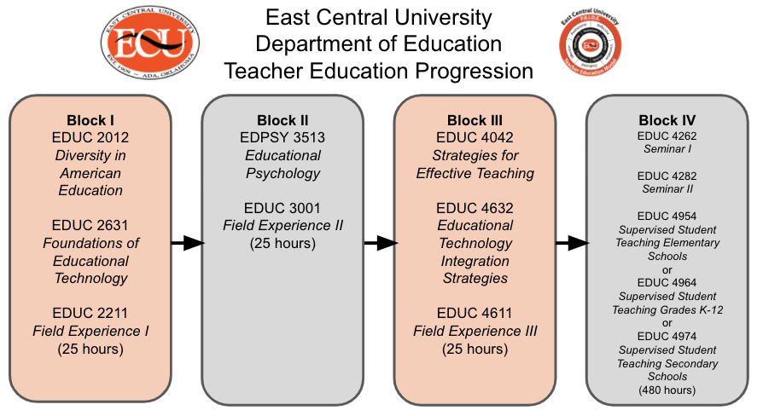
*During Block IV, students will enroll in two sections of EDUC 4954, EDUC 4964 or EDUC 4974 based on their major.

Professional Block I
Enrollment for Block I includes the following courses, which must be taken and successfully completed with a C or better during the same semester:
EDUC 2012- Diversity in American Education
Course Description: A historical, philosophical and organizational foundation of American education and global education. Elements of professionalism and the teaching profession.
EDUC 2631- Foundations of Educational Technology
Course Description: This course is designed to prepare pre-service teachers with hands-on opportunities to use productivity tools in their future classroom. There will be a focus on introducing a variety of educational application of technology.
EDUC 2211- Field Experience I
Course Description: A 25 clock hour laboratory experience in which potential teacher candidates observe in elementary, middle/junior high, and high schools to acquire a more mature perspective of the stages of development of students and the roles of teachers and other professionals.
A candidate cannot be enrolled in Block II or Block III courses while enrolled in Block I.

Professional Block II
Enrollment for Block II includes the following courses, which must be taken and successfully completed with a C or better during the same semester:
EDPSY 3513- Educational Psychology
Course Description: Application of psychological theories to classroom teaching. Primary course topics include educational research and the scientific approach to teaching; education measurement and evaluation; and theories of development, learning and motivation as they apply to classroom instruction, management and discipline.
EDUC 3001- Field Experience II
Course Description: Twenty-five hours of public school classroom and teacher laboratory experiences related to teacher preparation in general and specifically to those topics covered in EDPSY 3513 Education Psychology and EDUC 4632 Educational Technology.
A candidate cannot be enrolled in Block I or Block III courses while enrolled in Block II.

Professional Block III
Enrollment for Block III includes the following courses, which must be taken and successfully completed with a C or better during the same semester:
EDUC 4042- Strategies for Effective Teaching
Course Description: Development of learning units, lesson plans, instructional objectives, and evaluation techniques. Study of grouping and classroom management. Assignments will differentiate between elementary and middle school.
EDUC 4632- Educational Technology Integration Strategies
This course includes a blended style of instruction in which preservice teachers gain experience with using technology for learning, as well as integrating technology into classroom instruction. During this course students will be in the field or collaborating with instructional technology in their methods courses.
EDUC 4611- Field Experience III
Course Description: Twenty-five hours of public school classroom experience with the teacher candidate observing regular classroom events in general and specifically those related to topics covered in EDUC 4042 Strategies for Effective Teaching.
A candidate cannot be enrolled in Block I or Block II courses while enrolled in Block III.

Field Experiences provide guided practice in which candidates can begin developing desired teaching knowledge and skills. During a Field Experience, candidates are given an introduction to reflective practice and an opportunity to practice their skills, dispositions, and knowledge. Teacher candidates are encouraged to develop their own ideas, apply them to an educational setting, and be reflective in their evaluation of lessons and classroom environment.
For each of the Field Experiences, candidates are required to complete 25 clock hours in the classroom and may have a number of assignments to complete with accompanying block coursework. If a student fails to complete all of the Field Experience hours, he/she will either receive an Incomplete “I” or fail the course.

Application Requirements for Field Experiences
Prior to beginning field experiences, teacher candidates will apply for the appropriate field experience so that the Coordinator of Field Experience can begin communicating with the appropriate school district in order grant permission to begin in-school observation activities. Candidates are required to have the field application approved/confirmed prior to entering the school. If a candidate enters the classroom prior to approval/confirmation, a dispositional concern will be filed and the candidate risks being removed from the program. This process begins when students refer to the first Blackboard® assignment in the assigned field experience course.

To apply for all field experiences, the candidate must first be enrolled in the appropriate block coursework. Next, the student fills out the block appropriate field experience application/proposal, which includes:
- Submission of a cleared background check through Castle Branch located at https://www.castlebranch.com/
- Placement Proposals found in Blackboard for:
- Block I: 2 field placements (1 secondary and 1 early childhood/elementary)
- Blocks II-IV: 1 field placement (based on program of study)

Background Clearance
ECU requires all teacher certification students to provide verification of a cleared, current background check prior to each semester a student is engaging in field experience or clinical opportunities. The background check must be compliant and completed within the year the field experience is to occur. Students will have to complete the background check more than once. Background checks must be completed through www.castlebranch.com. Candidates may not participate in any field experience, whether for a professional education course or a methods course, without a current clearance on file.

Field Experience Placement Proposal
To monitor a teacher candidate’s Field Placement proposals, a form as been created to assist students in verifying they are following all the expectations of Field Experiences. To locate this form, please see the Appendix.
To apply for a Field Experience placement, a candidate must complete a placement request through a link provided in their Field Experience Blackboard course. Once the application for field experience or student teaching has been submitted, the Coordinator of Field Experience collaborates with Oklahoma public school administrators to arrange an appropriate classroom placement. During this time, candidates may not enter the classroom to fulfill any of their Field Experience Hours. The Coordinator of Field Experience maintains a relationship with districts and schools, and stays in touch with both candidates and administrators on a regular basis before, during, and after the placement process. After the Field Experience Coordinator and administrator accept the student’s placement, an email is confirmation email is sent to the student. The candidate will receive confirmation of the placement details including the school name, school address and phone number, principal name and email, mentor teacher name and email, grade assignment and start date. At this time candidates may begin fulfilling their Field Experience hours.
Standards of Professionalism During Field Experiences
During the in-school field experiences, candidates are expected to follow the principles, standards, and rules regarding proficiencies, dispositions/attitudes, and professional practice described in the ECU’s Department of Education Disposition Rubric, https://docs.google.com/document/d/1QDVO3MzgeVKz6KaoX43xX5_yONPpzH8IqtoskYrGdxo/edit?usp=sharing. Students should behave professionally before, during, and after school hours. Candidates need to strive to make a good impression and act in a professional manner at all times. Teacher candidates should:
- Arrive on time
- Dress professionally and attend to personal hygiene
- Wear any district required identification in plain sight at all times
- Keep field experience appointments- if an emergency arises and plans must be adjusted, the candidate should notify the school and teacher immediately
- Track all field experience hours on required times sheets and Chalk and Wire logs
- Use professional language in and out of the classroom with everyone (no profanity or overly casual language) with students and adults alike
- Demonstrate attentiveness and eagerness to learn
- Display a willingness to work with students from different cultures, different socioeconomic levels, and different learning abilities
- Be respectful to peers, families, teachers, staff, and administrators
- Be committed to meeting the educational needs of all students in a caring, nondiscriminatory, and equitable manner
- Demonstrate a belief that all students can learn
- Display persistence in the face of difficulty, stress, or adverse conditions
- Display a positive attitude toward teaching and learning
- Never use their cell phone for personal reasons
- Spend all time during the field experience time engaged in appropriate professional/educational activities
- Sign in and out in the office daily
- Thank the cooperating teacher and the office personnel during each visit
Evaluations of Field Experiences
During Blocks I, II, and III mentor teachers will receive an email outlining the expectations of each Block Field Experience as well as a copy of the evaluation. Evaluations during Blocks I-III can be completed and mailed or emailed to the Field Experience Coordinator once all Field Experience hours have been completed and before the end of the semester.

During Block IV, Student Teaching, evaluations will be emailed at the beginning, midterm, and the end of the semester. The evaluation during Student Teaching, which combines an evaluation over a student teacher’s disposition and his/her teaching skills, must be completed twice by cooperating teachers, student teachers, and university supervisors.
Field Experience I Evaluation
This assessment is completed during the Block I semester by mentor teachers at the conclusion of the field experience hours. The assessment is provided to mentor teachers through email as well as to students through Blackboard and during EDUC 2012, Diversity in American Education. This assessment was created in Spring 2017 and modified in how it is circulated in Fall 2018.
PDF of Assessment
https://drive.google.com/file/d/0B0D-tzaN2yrHbWpRV3QxWTdTVkE/view

Data Collected
https://docs.google.com/spreadsheets/d/1ae0V7tPl4Lr5IXATkRvxdA2cIFNqXFedfDhURdbCmeU/edit?usp=sharing

It is expected that students will score at least a 2.0 on this evaluation. For evaluations in which a score of at least a 2.0 is not achieved, the cooperating teacher will be communicated with to determine if a Disposition Concern is completed.

Field Experience II Evaluation
This assessment is completed during the Block II semester by mentor teachers at the conclusion of the field experience hours. The assessment is provided to mentor teachers through email as well as to students through Blackboard and during EDPSY 3513, Educational Psychology. This assessment was created in Spring 2017 and modified in how it is circulated in Spring 2019.
PDF of Assessment
https://drive.google.com/file/d/0B0D-tzaN2yrHSVNDUEw1TlJPWkk/view

Data Collected
https://docs.google.com/spreadsheets/d/1ae0V7tPl4Lr5IXATkRvxdA2cIFNqXFedfDhURdbCmeU/edit?usp=sharing

It is expected that students will score at least a 2.0 on this evaluation. For evaluations in which a score of at least a 2.0 is not achieved, the cooperating teacher will be communicated with to determine if a Disposition Concern is completed.

Field Experience III Evaluation
This assessment is completed during the Block III semester by mentor teachers at the conclusion of the field experience hours. The assessment is provided to mentor teachers through email as well as to students through Blackboard and during EDUC 4042, Strategies of Effective Teaching. This assessment was created in Spring 2017 and modified in how it is circulated in Fall 2019.
PDF of Assessment
https://drive.google.com/file/d/0B0D-tzaN2yrHSXM5eF82NEhZdFU/view

Data Collected
https://docs.google.com/spreadsheets/d/1ae0V7tPl4Lr5IXATkRvxdA2cIFNqXFedfDhURdbCmeU/edit?usp=sharing

It is expected that students will score at least a 2.0 on this evaluation. For evaluations in which a score of at least a 2.0 is not achieved, the cooperating teacher will be communicated with to determine if a Disposition Concern is completed.

Student Teacher Evaluation
This assessment is completed during the Student Teaching semester by cooperating teachers, student teachers, and university supervisors. This evaluation tool was updated in the Spring of 2017 and implemented during the Fall of 2017. Cooperating teachers, student teachers, and university supervisors complete the assessment twice during the semester- midterm and final.
PDF of Assessment
https://drive.google.com/file/d/0B0D-tzaN2yrHMWxBVnZJQVRUdDA/view

Link to Complete Assessment
https://docs.google.com/forms/d/e/1FAIpQLSdosT5BwbHzTewTqROr5KU-od4vWjQvNLaI13OciWIgHhp9zg/viewform?usp=sf_link

Data Collected
https://docs.google.com/document/d/1T1jmoIOXGw1dOZHQQ1wxfpsQVaGw73kzuDWoQ-w5_vI/edit

It is expected that students will score at least a 2.8 cumulative on this evaluation. For evaluations in which a score of at least a 2.8 is not achieved, the student will be contacted.

Issues During Field Experiences
If at any time, a mentor teacher becomes concerned with an ECU candidate in the field, please fill out a Dispositional Concern form https://goo.gl/forms/Yb1U2f8o2iFJ6UYB2, which will be brought to the attention of the Chair of the Department of Education or Coordinator of Field Experience.

Liability Insurance
Field Experience candidates and student teacher candidates in Oklahoma are subject to the same legal processes in cases of negligence or malfeasance as are regular teachers. Therefore, you are encouraged to acquire reasonably priced insurance. This liability insurance can be purchased in many ways. One way is through membership in student professional organizations.

Tiger PRIDE Notes

- Can anyone complete a Disposition Concern? Anyone, a faculty member, cooperating teacher, mentor teacher, etc., who has a concern about a future teacher’s disposition may complete a disposition concern.
- When completing my Field Experience will I be evaluated? Yes. Your mentor teacher will receive an evaluation, which can be accessed in Blackboard. You must receive a 2.0 on the evaluation.
- How many field placement proposals am I supposed to make in Blackboard
- Block I: propose 2 placements (1 early childhood/elementary and 1 secondary)
- Blocks II and III: propose 1 placement in the area of your program of study

CHAPTER 4: Student Teaching

Student Teaching Description
Teacher candidates at East Central University have the opportunity to work directly with PK-12 students and teachers during their final field experience of the education program. This capstone experience of the education program is known as a teacher candidate’s Student Teaching experience. This chapter focuses on the Student Teaching application, placement, and expectations.

Student Teaching Candidacy
ECU offers two cohorts a year: one that begins in August and one that begins in January. These are the only student teaching cohorts available. These times correspond with most Oklahoma school district schedules as well as when ECU’s College of Education offers the required cohort semester. Student teaching is not available during the summer.

Student Teaching candidacy is the final experience that a teacher candidate must complete in order to be eligible for ECU’s College of Education and Psychology recommendation for certification upon graduation. This experience provides candidates with the opportunity to develop and refine teaching skills in a supportive, real-world classroom environment. During Student Teaching candidacy, candidates will participate in an ECU cohort seminar with a group of peers that is facilitated by an experienced educator. All candidates are assigned a university supervisor to complete observations, evaluations, and provide support to teacher candidates in the classroom, as well as a cooperating teacher to work closely with throughout the semester. The university supervisor and cooperating teacher will provide regular, detailed feedback regarding a teacher candidate’s teaching performance and mastery of InTASC’s 10 Standards.
During this experience, candidates have the opportunity to experience all aspects of a school while interacting with students, parents, guardians, the university supervisor, the cooperating teacher, and other school personnel. Candidates are expected to encourage academic excellence in the classroom through their ability to implement effective, research-based practices in teaching. All evaluations are based upon the InTASC Model Core Teaching Standards found in Chapter 1 of this Handbook.
Director of Student Teaching
Once the application for student teaching candidacy has been submitted, the candidate is provisionally accepted to the cohort. At this time the Director of Student Teaching collaborates with Oklahoma public school administrators to arrange an appropriate classroom placement. The Director of Student Teaching maintains a relationship with districts and schools and stays in touch with both the candidate and administrators on a regular basis before, during, and after the placement process. When both the Program Coordinator and the Director of Student Teaching ensure that the candidate has met all final requirements, the candidate is considered to be accepted into the Student Teaching candidacy cohort. After this acceptance and school placement has been confirmed, the candidate will receive an email confirmation of the placement details including the school name, school address, phone number, principal’s name and email address, cooperating teacher’s name and email address, grade assignment, and start date. Until a placement has been confirmed, a student teacher is not allowed in the classroom.

Student Teaching Placement Guidelines and Restrictions
Student Teaching candidacy is a full-time, intensive, in-class experience that lasts for a minimum of 480 hours. Placement must be at the appropriate grade level in an accredited school in Oklahoma that meets ECU and state certification requirements. Currently ECU also offers two opportunities for teacher candidates to complete their student teaching abroad. For more information about student teaching abroad or outside of Oklahoma, please speak with the Chair of the Department of Education.

Length and Type of Placement
The student teaching candidate must be in the classroom full-time all day (as defined by the district). All hours present are to be recorded on a given time sheet and signed by the cooperating teacher and teacher candidate. It is the candidate’s responsibility to submit time sheets to the Coordinator of Field Experience & Student Teaching, and the university supervisor. Placement length and type of placement requirements for early childhood, elementary education, PK12 education, and secondary education are:

Early Childhood Education: Early childhood education candidate placements are a minimum of 480 hours with 240 hours in a pre-kindergarten or kindergarten setting and 240 hours in grades 1-3. Placements are made within the same school district.
Elementary Education: Elementary education candidate placements are a full-day, multi-subject elementary classroom for the entire placement, for a minimum of 480 hours.
PK12 Education (Art & Music): PK12 education candidate placements are a minimum of 480 hours long with 240 hours in an elementary setting and 240 hours in a secondary setting. Placements are made within the same school district.
Secondary Education: Secondary education candidate placements are a minimum of 480 hours long in a full-time teaching experience at the appropriate grade level and in the content area for which the candidate will be recommended for certification. Candidates may only be placed in the content area studied.

Employment During Student Teaching Candidacy
Student Teaching candidacy is a full time commitment. Those seeking Student Teaching candidacy may not participate in student teaching part time. Student teacher candidates are expected to be at the cooperating school district during all teacher contract hours including evening hours for school events and parent teacher conferences. This includes all assigned teacher duties as well. Student teaching candidates are also required to participate in the monthly ECU cohort seminar classes, which generally meet one day a month. It is also expected that substituting for absent teachers will be kept to no more than three days during the Student Teaching candidacy experience. Seminar days, days absent, and any days substituting (no more than three) must be recorded on the required monthly time sheet and emailed to the appropriate people each month.

Application Requirements for Student Teaching Candidacy
Before the assigned deadline for the cohort, the candidate must apply for student teaching and meet basic admission requirements. Once the candidate has applied and admission requirements have been confirmed, the candidate is provisionally accepted to the cohort. The application will be available in Blackboard® two months prior to the application deadline.
Application requirements for provisional acceptance to the cohort are that the candidate has completed the following:
- Single-sign on account created with the Oklahoma State Department of Education;
- Current, cleared background check on file with the Oklahoma State Department of Education. This background check differs from the background check completed in field experience. Candidates must have successfully completed a background check by the Oklahoma State Bureau of Investigation (OSBI) and the Federal Bureau of Investigation (FBI) prior to receiving a Teaching License. Fingerprint information may be reviewed at the Oklahoma State Department of Education (SDE) website. Candidates may submit two fingerprint cards to the OSDE in time for this review to be completed prior to the issuance of the License.
- Passing score on the Oklahoma General Education Test (OGET);
- Transcript showing at least 90 completed college hours;
- Letter showing admission to the ECU College of Education Teacher Education Program;
- Transcript showing completion of sufficient work during the junior or senior years at East Central University in the teaching program to provide an adequate basis for evaluation of readiness for student teaching;
- Certification of Program Coordinator approval of the academic preparation of the candidate to complete Student Teaching candidacy and that the previous three field experiences represent diverse settings with diverse populations;
- Transcript showing completion (or the equivalent of) EDUC 2012, 2402, 2631, 2211, 3001, 4632, 4042, 4611, EDPSY 3513, and PSYCH 3463;
- Verify second language competency at the novice level;
- Transcript showing a grade point average of 2.75 or better in major course work;
- Transcript showing a grade point average of 2.75 or better in all college work attempted and in university work attempted;
- Transcript showing a grade of “C” or better earned in the following Professional Education courses:
- EDUC 2402 Survey of Exceptional Children
- EDUC 2012 Diversity in American Education
- EDUC 2211 Field Experience I
- EDUC 2631 Foundations of Educational Technology
- EDUC 3001 Field Experience II
- EDUC 4632 Strategies for Implementing Educational Technology
- EDUC 4042 Strategies for Effective Teaching
- EDUC 4611 Field Experience III
- EDPSY 3513 Educational Psychology
- PSYCH 3463 Child and Adolescent Psychology

Unless a teacher candidate meets all of these requirements by the published deadline, the application will be denied. Once all requirements have been met and approved, candidates will be notified by email from the Coordinator of Field Experience & Student Teaching that they have been provisionally accepted to the cohort.

Application Withdrawal
Withdrawing from a student teaching course after the application is approved may have serious consequences. If a candidate withdraws after a district/school has accepted him/her for a candidate’s placement may have the potential of interfering with a successful placement in the future. It may also damage ECU’s ability to place other teacher candidates in the district.

For information about suspension, appeals, and dismissals of student teachers, please refer to Chapter 2.

Withdrawal From Two or More Student Teaching Courses
The East Central University College of Education and Psychology will guide the candidate, when approved, during a mandatory meeting session, through the enrollment process for the professional education courses required for the student teaching semester. The professional courses are as follows:

EDUC 4262 Student Teaching Seminar I
EDUC 4282 Student Teaching Seminar II
Then, the one pair of the following courses based on the student’s major:
EDUC 4954 Supervised Student Teaching Elementary Schools
EDUC 4954 Supervised Student Teaching Elementary Schools

EDUC 4964 Supervised Student Teaching Grades PK-12
EDUC 4964 Supervised Student Teaching Grades PK-12

EDUC 4974 Supervised Student Teaching Secondary Schools
EDUC 4974 Supervised Student Teaching Secondary Schools
If a candidate withdraws from two student teaching courses, they are no longer eligible to participate in a third student teaching course. However, if a candidate has experienced extenuating circumstances and wishes to appeal, he or she may do so.

Guideline for District Placement
In accordance with ECU’s Department of Education policy, student teacher candidates may not be placed in a district or school where the candidate:
- Has children or siblings currently enrolled;
- Has previously attended as a student;
- Has relatives or close friends who might serve in a supervisory capacity;
- Has a relative, by blood or marriage, on the district board of education;
- Has completed two other field experience assignments; or
- Has been or is now employed.

Cooperating School Selection for Placement
When students apply for Student Teaching candidacy, they indicate their top three preferred districts on the application through Chalk and Wire. The Coordinator of Student Teaching does her best to place students in their preferred district and school, but applicants must be aware that is not always possible. If a placement is not available in the applicant’s preferred district, the Coordinator of Student Teaching will seek a placement for the candidate in one of the other two choices. Applicants should not make concrete plans around a placement until official notification that the placement is confirmed and that the candidate has met all requirements to be fully accepted to the cohort has been received. Finding a placement that is close to home is not always possible. Applicants may be expected to travel, in rare cases, depending on the availability of placements in selected area and content area. Placement is not guaranteed although the Coordinator of Field Experience & Student Teaching will make every effort to secure one.

Student Teaching Candidacy: Following Full Acceptance
Approximately one month prior to the start of the student teaching semester, the Coordinator of Field Experience & Student Teaching will email the candidate additional information regarding student teaching. The Coordinator of Student Teaching will have already provided the cooperating principal and cooperating teacher with the information they need to make the student teaching semester a success. During the Student Teaching Seminar I (EDUC 4262), the seminar instructor(s) will provide each candidate with additional information and support. In addition, the candidate can always have questions answered and connect with the Coordinator of Student Teaching and Field Experience via email or telephone.

Student teaching is one of the most significant experiences in a candidate’s preparation to become a professional educator. It is the culmination of the teacher preparation program in which the candidate continues the process of blending theory and practice into the art and science of teaching. Student teaching is a part of a genuine capstone event, during which the candidate completes the prescribed knowledge base and demonstrates the ability to apply the teaching skills necessary for entering the profession as an educator. The following points help clarify the expectations of the student teacher candidate:
- The teacher candidate knows and maintains the policies of the East Central University and the cooperating school and district. Candidates are responsible for becoming familiar with the guidelines outlined in this handbook. Candidates should also ask the principal or cooperating teacher for access to appropriate faculty and student handbooks containing policies and regulations for the assigned school district;
- The teacher candidate knows and follows the code of ethics of the teaching profession. Candidates should become familiar with the code of ethics of the teaching profession and adhere to these tenets in all matters dealing with students, the public, fellow professionals, and when seeking employment;
- The teacher candidate identifies him/herself as a professional educator. Assumes the role of a teacher in relationships with the students and in all areas of conduct both at school and in the community. Candidates should never allow students to call them by their first name. Candidates should also spend lunch periods and other breaks with teachers and/or other professional personnel and not with students or always with other student teacher candidates;
- The teacher candidate dresses appropriately. Candidates are expected to look and behave like teachers. It is important to be well groomed and dressed in a manner that would be appropriate for a teacher in the given school and subject;
- The teacher candidate observes the schedule of cooperating school and district. Candidates are expected to maintain the same working hours and holidays as the cooperating teachers. They may have to be absent because of illness or important personal business, but should never be absent without notifying the school and cooperating teacher as soon as possible. The same consideration applies to unavoidable tardiness; the cooperating school should be called immediately. If candidates are absent more than 3 times during the semester, we are concerned. If there are more than 5 absences the University Supervisor is to be contacted. Excessive absences, generally more than five during a semester, must be made up regardless of the reason(s) before credit can be earned. The Director of Student Teaching, in consultation with the university supervisor, will schedule the make-up days. In the event of unusual circumstances, situations will be considered on a case-by-case basis;
- The teacher candidate keeps track of appropriate hours present, absent, substituting (no more than three) and seminar meetings as assigned during the cohort seminar course. Teacher candidates are expected to keep the daily arrival and departure time of their cooperating teacher (i.e. if district requires teacher to report at 7:40AM and leave no earlier than 3:45PM, the teacher candidate will do the same). The time logs should be emailed to the Coordinator of Field Experience & Student Teaching, and the university supervisor at the end of each month;
- The teacher candidate becomes familiar with the school community. If candidates are not familiar with the school and community, they need to become acquainted;
- The teacher candidate uses observation time wisely. Understanding how time is allocated and utilized is an important part of the student teaching experience. Candidates should study the cooperating teacher’s techniques of classroom management to note how presentation of new material is paced and to become acquainted with the students. Candidates should learn students’ names as soon as possible. Candidates should try to know every student’s name by the end of the first week in a self-contained classroom and no later than the end of the third week in departmentalized situations. It is helpful to observe each child’s level of motivation, responsiveness, attitudes about school, and social interaction;
- The teacher candidate carefully plans lessons and reflects on improvement (Improves the student teacher’s teaching.) Diligent preparation and reflective evaluation are keys to improving teaching performance. Do not mistake how well the cooperating teacher presents lessons with what may appear to be very casual planning. He or she has probably taught those lessons many times and has refined the presentation with each repetition. Beginning teachers need to plan carefully and specifically in order to have successful lessons. Candidates should analyze each lesson taught to determine how it might be improved and seek suggestions for improvement from the cooperating teacher;
- The teacher candidate seeks the advice and counsel of the professional team (cooperating teacher, university supervisor, and coordinator of student teaching). All student teachers have questions and experience some problems. The first step in resolving a problem is to have an open discussion with the cooperating teacher and /or university supervisor;
- The teacher candidate respects the differences between the roles of the student teacher and the cooperating teacher. The cooperating teacher is ultimately responsible for the welfare of the students. When there is a difference of opinion as to how something should be done, you should comply with the wishes of the cooperating teacher. Because of legal ramifications, A STUDENT TEACHER SHOULD NEVER ADMINISTER CORPORAL PUNISHMENT;
- The teacher candidate volunteers assistance. Simply doing what is asked is not enough for a successful student teaching experience. Candidates should volunteer to assist with any task being done by the cooperating teacher, or to help individual children when involved with only part of the class;
- The teacher candidate assists with non-teaching duties. A teacher’s role extends beyond the classroom. It is expected that you will assist with, or in some instances assume, any duties assigned to the cooperating teacher such as hall duty, playground duty, ticket-taking at ball games, etc. Candidates should attend all appropriate faculty meetings, in-service workshops and meetings of parent-teacher organizations. The cooperating teacher, principal and university supervisor will determine the appropriateness of participation in parent-teacher conferences or visitation in students’ homes;
- The teacher candidate clears non-routine class activities. Any activities that are outside of the regular classroom routine such as field trips, guest speakers, parties, etc. should be approved by the principal in advance.
- The teacher candidate limits substitute teaching. Candidates are expected to help in emergency situations but should not be taken advantage of to the point that it interferes with the rationale for, and the continuity of, the student teaching candidacy experience. The faculty believes that a candidate should not be asked to substitute outside of their assigned classroom more than three times. If a candidate feels that they are being asked to substitute too frequently, then they should discuss the situation with their university supervisor;
- The teacher candidate assumes legal responsibility. Student teachers in Oklahoma are subject to the same legal processes in cases of negligence or malfeasance as are regular teachers. Therefore, candidates are encouraged to acquire the reasonable priced insurance offered through membership in a Student Education association;
- The teacher candidate attends student teaching seminars. Candidates are to be at their assigned school all assigned days/hours except scheduled meetings for your seminar cohort. Days scheduled for seminar may be counted toward student teaching days;
- The teacher candidate submits required paperwork. Lesson plans are to follow any template or expectation used in education coursework and should be emailed to the university supervisor three days prior to each scheduled visit. At the end of each month, the time sheet is to be emailed to the university supervisor and the Coordinator of Field Experience & Student Teaching.

Teacher Candidate Responsibilities
Candidates are expected to act professionally at all times and work with the cooperating teacher, the university supervisor, seminar cohort facilitator(s), and professional colleagues to strengthen skills and knowledge. The goal of the student teaching experience is to provide candidates with the maximum opportunity to perform to the degree which personal interests, abilities, and individuality allow. Student teaching is a full-time commitment. Participation in all education activities of the school is regarded as an integral part of the student teaching experience and is not to be regarded as optional or supplemental. It is also expected that the candidate will inform his/her cooperating teacher of lesson plan requirements for the week’s lesson plan for the teacher candidate’s PPAT®. During the student teaching experience, candidates (1) participate in the activities in the classroom and cooperating school; (2) participate in the monthly cohort seminar classes; and (3) continually reflect and document their experience and professional growth through PPAT® Tasks and the professional electronic portfolio in Blackboard

Adherence to School Calendar
Candidates must follow the calendar of the cooperating school district and school. This includes attending pre-service days and parent-teacher conferences. Candidates are required to participate in all professional activities in which the classroom cooperating teacher participates. In the first week, candidates should ask the cooperating teacher about his or her expectations regarding arrival and departure times. He/she is required to keep the same hours as the cooperating teacher and participate in all professional development activities. Generally, the candidate will need to be at the school 30-45 minutes before class starts and to remain after school 45 minutes to an hour. If the cooperating teacher is absent, the candidate is still required to report to school and work with the assigned substitute teacher.

Adherence to School District Rules and Policies
School policies may vary from school to school. Upon arriving at the school, the candidate should immediately become familiar with the school’s policies such as zero tolerance, incident reporting, universal health precautions, safety drills and regulations, and the physical facilities of the school. The cooperating teacher and/or building administrator should help with this orientation to the school. ECU’s Department of Education expects the candidate to comply with all policies—attendance and otherwise—as required by the cooperating school and district.

Some key rules to follow and expectations the teacher candidate needs to keep in mind include:
- Review school policies, procedures and regulations with the host teacher, including emergency procedures. Read the school policy manual and comply with all school district and building regulations;
- Observe the standards of dress appropriate to the teaching profession and in accordance with the school and district policy;
- Provide the cooperating teacher and school with a current phone number, mailing address and e-mail address, and continue to check MyECU email daily;
- Be on time when reporting to school and be regular in attendance. Candidates are expected to attend school each day unless an extreme illness or emergency occurs, arriving at school promptly and remaining throughout the school day. Schedule doctor appointments and other business outside of school hours. Keep track of hours on assigned monthly time sheets being sure to obtain cooperating teacher’s signature each month before submission;
- Notify the building principal and cooperating teacher, in addition to the university supervisor, as far in advance as possible, of tardiness or absence;
- Do not leave the school campus during the school day to run errands or to eat lunch.
- Be sensitive to the values and expectations of the school community;
- Be considerate and courteous to students, parents, building teachers, and other school personnel;
- Attend school events as requested by the host teacher or principal;
- Volunteer and assist with routine procedures and non-teaching duties as assigned by the host teacher;
- Turn off cellular devices while school is in session and do not make or accept personal calls or texts during the school day;
- Secure a copy of the school’s policy on computer and internet use, and abide by it. Do not use school computers to check email or social sites;
- Maintain frequent contact with the cooperating school’s principal, staff and other faculty;
- Interact professionally with colleagues, students, office and all non-teaching school staff, parents, and district personnel;
- Respect the confidentiality of the classroom cooperating teacher, student, and school personnel. Candidates must observe professional ethics and Family Educational Rights and Privacy Act (FERPA) regulations when there is a need to discuss student problems with parents, guardians, or other teachers;
- Apply only those disciplinary methods, conflict resolution, and behavioral procedures that have been approved by the school district and that do not undermine the dignity or the basic human rights of individuals such as corporal punishment.

Meeting the Cooperating Teacher Expectations
- A cooperating teacher is a mentor, and a teacher candidate is an invited guest in his or her classroom. Accordingly, the teacher candidate should act professionally, be prepared, and be respectful at all times;
- Acknowledge the cooperating teacher as the ultimate authority within the classroom and assume only authority delegated by the cooperating teacher. The cooperating teacher is legally responsible for the program of instruction in the classroom;
- Obtain approval from the cooperating teacher prior to experimenting with any new or novel approach in delivering instruction and dealing with student conduct or behavior. This includes modification of classroom management systems and procedures for maintaining materials, resources, and schedules. If the cooperating teacher is unwilling to have the instruction or management plan modified, graciously accept the decision.
- Become familiar with the cooperating teacher’s record keeping, grading, and reporting;
- Learn as much as possible about each student, especially those with special needs or whose first language is not English (ELL Students);
- Adequately plan and organize academic and other classroom activities;
- Prepare and submit lesson plans directed and prescribed by the cooperating teacher, university supervisor and/or cohort seminar facilitator. Always prepare lesson plans for the cooperating teacher to review prior to implementing lessons. Co-planning and co-teaching are prerequisites to assuming full planning and instructional responsibilities;
- Inform the cooperating teacher of all parental contacts and the nature of pertinent communications with parents. Communicate in a professional manner with students, parents, and other professionals;
- Share concerns and problems with the cooperating teacher before they develop into more serious problems.
- Seek advice, feedback, and constructive criticism from the cooperating teacher and university supervisors. Allow ample time to confer regularly with the cooperating teacher;
- Take on all aspects of teaching in the classroom (planning, instruction, assessment, guidance, and classroom management) for a minimum of 4 to 6 weeks;
- Collaboratively make arrangements for classroom observations from the university supervisor with the cooperating teacher. The school needs to be aware of visitors at all times.

Lesson Plans
Follow established guidelines and school policies for developing lesson plans while student teaching in the field. Generally, use the same lesson planning procedures and format as the cooperating teacher except when completing Task 2 of the PPAT. If the cooperating teacher does not specify a lesson plan format, use any lesson plan format that has been used in the education coursework or that the university supervisor requests. Discuss with the cooperating teacher or university supervisor when and how he or she expects you to submit the lesson plans. Be sure to submit the lesson plans to the cooperating teacher as directed. In addition, be sure to submit lesson plans to the university supervisor at least three days before a scheduled observation visit. Finally, always have lesson plans readily available so that the university supervisor, cooperating teacher, and/or school principal can look over the lesson plan if there is an unannounced observation or question about a lesson.

Absentee Policy
Candidates are expected to attend every day of the scheduled student teaching candidacy with no absences. If the cooperating teacher is expected to be at school, so is the candidate. If the cooperating teacher is absent, candidates are still expected to be at school. Candidates follow the same school calendar as the cooperating teacher. Candidates are expected to attend all professional development meetings and activities that are required of the cooperating teacher.

Occasionally, emergencies arise such as illness or weather closure. In these emergency cases, candidates are permitted no more than five absences during the student teaching candidacy experience. If the candidate is absent without approval, or if the candidate has more than five days of approved absences, the candidate is subject to meet with the Coordinator of Student Teaching and chair of the Department of Education. Attendance should be recorded on the monthly time sheet which is turned in to the university supervisor and the Coordinator of Field Experience & Student Teaching.

Making Up Missed Days
If a candidate misses more than five approved days for weather closure, they will be required to make up those hours/days by adding an additional full week or more to the length of their student teaching. In most cases, the school will schedule make up days. If this is the case, simply make days up as scheduled. However, if the candidate is scheduled to have student teaching candidacy finished before the scheduled make-up days, the candidate will be responsible to add the make-up days to the end of their schedule.

Teachers College Code of Professional Behaviors and Dispositions
Teacher candidates and graduates are expected to follow the principles that define the proficiencies, dispositions, and professional practice expected in the field of education. The principles pertain to a teacher’s commitment to the student, the profession, and the district and school. Candidates are also expected to refrain from all unethical conduct as described in the Code of Professional Behaviors set forth by the National Education Association (NEA) (Code may be found in Chapter 1). If not, candidates may be subject to removal from the program in accordance with the process for disciplinary action included in this handbook.

Failure to Follow Standards of Professionalism
Failure to follow standards of professionalism and the Code of Professional Behaviors or poor performance may result in intervention or discipline actions that could include removal from student teaching, removal from the program, and/or expulsion from the university. If concerns arise that cannot be resolved with the cooperating teacher and cooperating school district, or with the university supervisor, the candidate must contact the Coordinator of Field Experience & Student Teaching for support.

The ECU College of Education and Psychology reserves the right to terminate a student teaching placement if the East Central University College of Education and Psychology or the school district determines that the teacher candidate demonstrates unacceptable professional performance, conduct, or if the teacher candidate is unable to sustain an adequate level of learning for the students in his/her classroom. The cooperating school and the district reserve the right to terminate placement at their discretion if they believe it is in the best interest of their students to do so. When the Department of Education becomes aware of a problem, the Coordinator of Field Experience & Student Teaching will contact a teacher candidate by phone and email to notify him/her of the issue. Depending upon the severity of the problem and the desires of the cooperating teacher and school, the candidate may be referred to the Teacher Mentoring Committee for a plan of immediate improvement, or he/she may be withdrawn administratively and ultimately fail the student teaching candidacy experience.

Cohort Seminar
Cohort Facilitator(s)
The cohort facilitator, a teaching professional, provides comprehensive advisement and support during the Student Teaching candidacy. Seminar facilitators lead monthly face to face meetings dealing with common issues of interest, importance, and classroom management as well as monitoring progress, including construction of the PPAT® work samples. He/she also provides candidates with resources and guidance as they work to correct deficiencies or concerns, they may have regarding teaching standards and objectives. If there are any concerns about placement and the teaching experience, candidates should let their seminar facilitator know immediately, or they may contact the Coordinator of Field Experience & Student Teaching.

PPAT: Preparation for Critical Dimensions of Teaching
The PPAT® process identifies and collects subject-specific evidence of effective teaching from a learning segment of 3-5 lessons from a unit of instruction for one class of students. Teacher candidates submit authentic artifacts from a clinical field experience. Candidates also submit commentaries that provide a rationale to support their instructional practices based on the learning strengths and needs of students. Teacher candidates’ evidence is evaluated and scored within the following four tasks:
- TASK 1: Knowledge of Students and the Learning Environment: In this task, teacher candidates will demonstrate the knowledge and skills that pertain to their understanding of the classroom regarding students, the school, and the community, and they will identify the implications of these factors on instruction and student learning.
- TASK 2: Assessment and Data Collection to Measure and Inform Student Learning: In this task, teacher candidates will demonstrate understanding, analysis, and application of assessment and data collection to measure and inform student learning.
- TASK 3: Designing Instruction for Student Learning: In this task, teacher candidates will demonstrate their ability to develop instruction, including the use of technology, to facilitate student learning.
- TASK 4: Implementing and Analyzing Instruction to Promote Student Learning: In this task, teacher candidates will demonstrate their ability to plan and implement a lesson using standards-based instruction. They will also show how they are able to adjust instruction for the whole class as well as for individual students within the class. Finally, they will demonstrate an understanding of reflective practice.

The PPAT® (Performance Assessment for Teachers) process is built around three-to-five continuous days of standards-based, subject-specific classroom instruction delivered by a teacher candidate. PPAT® is a multiple-measure assessment of teaching—built and submitted by the candidate—that addresses planning, instruction, assessment, and analyzing the candidate’s teaching. The assessment includes unedited video recordings of the candidate teaching and examples of teaching materials (plans, teaching tools, assignments) that demonstrate how the candidate planned instruction, adapted it for diverse learners—attending both to subject specific learning and the development of academic language—and assessed student work.

Each assessment is scored nationally by qualified and trained teachers and teacher educators who are content area experts with experience of supporting beginning teachers. Half of the current scorers are recruited from higher education and half are recruited from PK-12 educators, including National Board Certified Teachers.

The PPAT became a part of Oklahoma’s Teacher Certification process in 2020. It replaced the OPTE. The feedback provided to teacher candidates and institutions will support ongoing inquiry and professional learning. PPAT® offers a rigorous measure of entry-level teaching skills and readiness for the classroom—regardless of the path teacher candidates take to teaching—that can be used across programs, focusing attention on the capacity to effectively teach all students in an innovative and engaging manner.

PPAT® Tasks and Evidence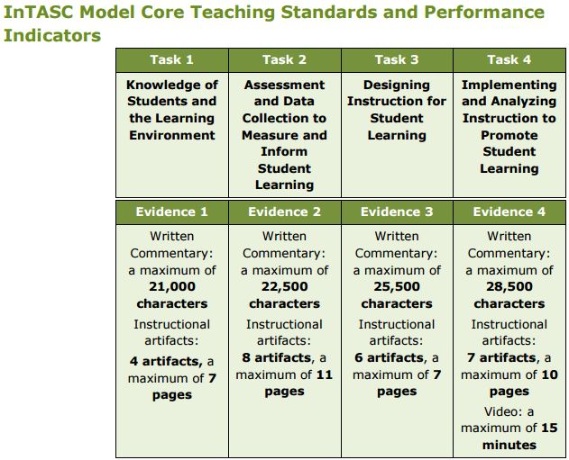
More thorough information about the PPAT® tasks and associated evidence can be located at: https://www.ets.org/s/ppa/pdf/PPAT® -candidate-educator-handbook.pdf.
Educational Testing Services (2016). PPAT Candidate and Educator Handbook.

Guidelines for Supporting PPAT® Candidates
PPAT® is a summative, subject-specific portfolio-based assessment of teaching performance, completed during a teacher preparation program with a clinical field experience. PPAT® is designed to assess a teaching candidates’ readiness for certification.

Given the placement of PPAT® within an educational program, professional conversations about teaching and learning associated with the outcomes assessed in PPAT® are encouraged. Consistent with research on student learning (Black and Williams, 1998), programs are encouraged to help candidates examine the outcomes of the assessment in meaningful ways and discuss how they will demonstrate their performance in relation to those outcomes.
Teacher candidates are learning how to teach and are being guided by more experienced teachers, often in co-teaching contexts. Educators offering support should discourage any attempts by candidates to fabricate evidence or plagiarize work. However, many, if not most, candidates will use or adapt curriculum materials developed by others. Candidates should cite the source of adapted materials, including materials received from experienced teachers. Professional responsibilities for candidates as they develop evidence for PPAT®, including protecting confidentiality, citing sources of materials, etc. are outlined in the PPAT® handbook.

Strategies for Formative Support
Formative support may be offered during academic terms prior to the completion of PPAT® in a clinical experience or may extend early in the student teaching semester in which PPAT® is formally developed and submitted.

Acceptable forms of formative support include:
- Providing explanations of terminology and concepts covered by PPAT®
- Examining the language, structure and progression of the PPAT® rubrics during formative experiences throughout the program
- Assigning formative tasks during coursework, e.g., analyzing video clips of teaching and learning, constructing a unit of instruction, assessing student work
- Distributing PPAT® support documents such as Making Good Choices
- Discussing samples of previously completed PPAT® portfolio materials (with appropriate permissions granted)
- Using the rubrics for evaluating course assignments or other formative assessments in the program
- Using rubric constructs or rubric language to debrief observations made by field (university) supervisors or cooperating teachers as part of the clinical supervision process
- Offering candidates seminars focusing on the skills and abilities identified in the PPAT®, such as an Academic Language seminar.
- Arrange technical and logistical support for video recording and uploading documents into electronic platforms.

University supervisors and cooperating teachers can support the PPAT® process by inquiring when the deadlines are or offering assistance to teacher candidates throughout the student teaching semester.

Cooperating Teacher
Cooperating teachers (CT) have the most contact with student teacher candidates and will usually have the most influence on their careers. The cooperating teachers serve as the communication link between student teachers, the PK-12 school community, and the university. They are the key person in planning the actual teaching experience with student teacher candidates and other professional team members, which also includes university supervisors and the Coordinator of Student Teaching. Only master teachers with at least three successful years of teaching experience are to be selected as cooperating teachers.
The cooperating teacher is the teacher in the school who has invited the candidate to participate in his or her classroom. He or she is an experienced teacher and in most instances has had previous experience mentoring student teachers. The student teacher candidate should always remember that they are a guest in the cooperating teacher’s classroom and should behave accordingly. The cooperating teacher will interact with the candidate daily and will complete a midterm and final evaluation of student teaching performances by using the InTASC Model Core Teaching Standards imbedded in the Student Teacher Evaluation. The following points help clarify the expectations of the cooperating teacher:
- He/she discusses expectations of the student teaching candidate;
- He/she arranges for daily conferences;
- He/she facilitates conferences between candidates and their university supervisor;
- He/she discusses and evaluates the teacher candidate’s lesson plans;
- He/she becomes aware of the requirements of the candidate’s PPAT® Work Sample;
- He/she becomes aware of the InTASC Model Core Teaching Standards;
- He/she helps the candidate plan for the actual hours/days of teaching;
- He/she helps the candidate plan classroom management and discipline;
- He/she included the candidate in instructional planning;
- He/she supports the candidate in extraordinary situations;
- He/she evaluates and discusses evaluations with candidate;
- He/she keeps a record of candidate absences;
- He/she notifies the university supervisor of significant changes;
- He/she attends the Cooperating Teachers’ Seminar/Dinner with the student candidate.
- He/she remembers that the teacher candidate is a student continuing to learn the craft of the profession.

Qualifications of the Cooperating Teacher
Research indicates that the selection of the cooperating teacher is one of the most important factors in the student teaching experience. Because the school’s principal knows the strengths of particular faulty better than anyone else, the university heavily relies on him/her to help connect the cooperating teacher with our student teacher candidate. Therefore, it is East Central University’s policy that the principal, working with the Coordinator of Student Teaching, controls student teacher candidacy placement within the guidelines established by the Oklahoma State Department of Education and East Central University. These requirements stipulate that a cooperating teacher:
- Should have a minimum of 3 years’ experience in the teaching profession with 1 year in the district and certification in the requested area(s);
- Will accept responsibility for guidance, communication, and evaluation of the teacher candidate as required by the ECU Department of Education;
- Will have knowledge in the content subject areas and will provide a positive, nurturing environment for the teacher candidate;
- Will need to attend the CT Seminar in person or follow-up with the office Field Experience & Student Teaching to make other arrangements if unable to attend.

Cooperating Teacher Presence in the Classroom
At the Cooperating Teacher Forum, the cooperating teacher will be given commentary as to the highlights in this handbook as well as valuable information regarding evaluation of the teacher candidate and information regarding the PPAT® Teacher Work Sample which the student teacher candidate must complete for the seminar cohort of the semester. It is ideal to allow the student teacher candidate to teach independently for at least 4 to 6 weeks of the student teaching candidacy in order to gain first-hand experience. The East Central University Department of Education is not opposed to implementing a Co-Teaching situation with the cooperating teacher and the teacher candidate. The Department of Education asks that the cooperating teacher remain in an active supervisory role with the student teacher candidate during the full candidacy.

Responsibilities of the Cooperating Teacher
As a cooperating teacher, he/she acts as a mentor providing high quality modeling, teaching expertise, opportunities for learning and teaching, and support to the student teacher candidate. The responsibilities include:

- Being familiar with the Cooperating Teacher Chapter of the ECU Teacher Education Handbook
- Serving as the communication link between the student teacher candidate and the school community. The cooperating teacher should do the following as early as possible:
  - Introduce the student teacher to other faculty and support personnel. Student teacher candidates should know the names/functions of significant personnel within the school by the end of the first week.
  - Explain relevant school policies and regulations. Student teacher candidates should have access to faculty and student handbooks. They should be well acquainted with policies and regulations regarding teacher expectations, students, parking, faculty lounges, workrooms, the cafeteria, duplicating equipment, the library, media equipment and materials, etc.
  - Acquaint the student teacher with physical facilities and support services available. Explain how these facilities and support services are to be used and the necessary procedures to follow.
  - Explain emergency procedures. Student teacher candidates need to understand the school’s policies regarding fire, tornado, and other drills. They must be aware of policies involving a child’s leaving school with someone other than a parent. They should be alerted to other specific situations such as a child who might require closer attention because of a medical problem.
  - Provide necessary teaching resources and a place for the student teacher candidate. They should have a copy of any textbook to be used, available curriculum guides, teaching outlines, etc. Please explain if some resources are restricted to use at school and are not to be taken from the building.
  - Prepare the class for the arrival of the student teacher. It would be helpful if the students understood the student teaching candidacy process. Introduce the student teacher candidate to the class.
- Planning with and supervising the student teacher candidate.
  - Discuss expectations. The cooperating teacher and the student teacher candidate need to be aware of their expectations of each other.
  - Arrange for daily conferences. Set a daily time for private discussions and a weekly time for a more detailed evaluation and progress report with the student teacher. Successful student teaching candidacy requires open and assertive communication. Feedback is necessary for growth.
  - Facilitate conferences between the student teacher candidate and the university supervisor. The university supervisor will visit and/or observe the student teacher a minimum of three times with visits scheduled in advance. He or she will usually want to visit privately with both the cooperating teacher and the student teacher candidate. Please help us by arranging care for the class while the student teacher and the supervisor confer and by providing a place that affords some degree of privacy.
  - Become aware of the InTASC Model Core Teaching Standards. The InTASC Standards are the standards for which both the cooperating teacher and university supervisor use for midterm (cooperating teacher) and final (cooperating teacher and university supervisor) evaluations of student teacher candidates.
  - Paperwork required of student teachers candidate. It is suggested that lesson plans be shown to the university supervisor during each visit. All candidates are required to complete a unit lesson plan and video per requirements of the PPAT® associated with the candidate’s ECU Seminar coursework. This unit plan is just one part of the student teaching candidacy. The candidate will also create other lesson plans under the direction of the cooperating teacher to be used in the classroom environment. Candidates are required to record attendance on a monthly timesheet, which is required to be signed by both the candidate and the cooperating teacher. The timesheet should then be submitted via email to the university supervisor and uploaded to the seminar Blackboard® shell.
  - Plan for the actual hours of teaching. The student teacher candidate’s timeline will begin when their cooperating teacher reports for pre-service training in the fall and when cooperating teachers report back in the spring. The 480 hour time requirement will begin from that day. The student teacher candidate should be allowed observation time to become acquainted with the cooperating teacher, the students, the daily schedule, and the building procedures before assuming any responsibility for actual teaching. During observation time, he or she may be asked to check roll, grade papers, or help individuals or small groups. Within a few days, he or she should be ready to present a lesson, and from this point the experienced cooperating teacher will be able to determine how much responsibility to add and at what rate. The cooperating teacher should feel free to discuss any uncertainty about the progression with the student teacher candidate and/or the university supervisor. If progress is normal, the student teacher candidate should be ready to teach a full schedule and be in complete charge of the classes four to six weeks prior to the end of student teaching. We suggest that there be time for observation and orientation and then progressively increasing involvement in the teaching process until there is full involvement. A cooperating teacher may wish to start the actual student teaching and add responsibility as new units of study are begun, or at some other natural point of transition. Many teachers feel that their students, as well as the student teaching candidate, can best be served by team teaching rather than turning all the classroom activity over to the student teacher candidate for the last few weeks. Some cooperating teachers like to gradually resume their teaching as the end of the student teaching candidacy approaches. If this is desirable it may be possible for the student teacher candidate to spend some time observing other teachers or other professionals in the school such as speech therapists or resource teachers.
  - Classroom management and discipline. Explain school policies and practices. Make sure the student teacher candidate has a copy of the student handbook, faculty handbook, and other relevant material. Integrate theory and practice. Student teachers are NOT to use corporal punishment.
  - Include the student teacher candidate in instructional planning. Inform the student teacher candidate about the objectives and goals of a unit of study and explore alternative approaches to achieving and evaluating the attainment of these goals. Set the boundaries of the unit with the student teacher candidate, and then allow room for creativity within these boundaries.
  - Support the student teacher candidate in extraordinary situations. It is expected that the cooperating teacher will shelter the student teacher from extreme disciplinary problems that arise and in cases involving agitated parents. Because of legal ramifications, student teachers are NOT to use corporal punishment.
  - Substituting should be limited to no more than three days. Candidates are expected to help in emergency situations, but should not be taken advantage of to the point that it interferes with the rationale for, and the continuity of, the student teaching candidacy experience. The faculty believes that a candidate should not be asked to substitute outside of their assigned classroom more than three times. If a candidate feels that they are being asked to substitute too frequently, then they should discuss the situation with their university supervisor.
  - Review the evaluation with the student teacher candidate. These evaluations should be discussed with the student teacher candidate and the university supervisor. Be frank and assertive in both the evaluation and the conference in order that the student teacher candidate may be alerted to any area of concern. The cooperating teacher will be asked to complete a mid-term evaluation and a final evaluation. With the final evaluation, the cooperating teacher will be asked to fill out and submit a disposition evaluation of their teacher candidate. These forms are all electronic and the links will be sent in an email at mid-term and close to the end of the student teaching experience. At completion, the forms will be automatically submitted to the Director of Student Teaching.
  - Keep a record of absences. Students are required to attend a once a month seminar meeting on the campus of East Central University. This day is not counted as an absence. Excessive absences by the student teacher must be made up regardless of the reason. If he/she misses more than three days, we are concerned. If he/she misses more than five days, please contact his/her university supervisor. In cases of excessive absenteeism, generally more than five days during the semester, the Director of Student Teaching, in consultation with the university supervisor, will schedule the makeup hours/days. In the event of unusual circumstances, situations will be considered on a case-by-case basis.
  - Notify the university supervisor of significant changes. Although student teacher candidates have been screened carefully, there may be occasions when it is necessary to recommend further experiences or professional guidance to help someone find more satisfactory career opportunities. The cooperating teacher is asked to notify the university supervisor promptly if behavior indicating the above is observed. If such a situation occurs, the Director of Student Teaching and the professional team will decide what they believe to be the best course of action for that particular student teacher. In most instances he/she can withdraw from student teaching and receive a non-teaching degree.
  - Attend the Cooperating Teachers’ Dinner/Forum. At the beginning of each semester, a seminar will be held for cooperating teachers where experiences will be shared and problems discussed in order that the student teaching candidacy program might be improved. University supervisors are encouraged to attend part of or this entire seminar.

The Initial Meeting of Teacher Candidate and Cooperating Teacher
Many hopes and anxieties are brought to the first meeting between the cooperating teacher and the student teacher candidate. Both parties know that they will be working in an extremely close and special relationship for the coming weeks. The insights about one another that each teacher gains during this initial meeting will set the tone for the coming weeks.

The two teachers, one with experience and one hoping to become experienced, will want to share some things about their background, their personal and professional interests, their hopes about teaching in general, and for this specific situation, possibly some of their apprehensions. The best atmosphere for this meeting is one of openness and frankness. This meeting initiates the realities of an indispensable part of the training of a teacher candidate—his or her internship with the cooperating teacher.

The First Day of Class
One of the most helpful activities of a cooperating teacher is to help the student teacher candidate be fully prepared for the first day of class. This first day sets the tone, sometimes for the whole year, for classroom management, routine, learning environment, and other areas of teaching. Sharing bulletin board ideas, ideas for meeting and greeting students, and ideas for handling routines efficiently are ways the cooperating teacher can help. Also, be direct with the cooperating teacher’s expectations of the teacher candidate.

Unannounced Observations by University Supervisor of Teacher Candidate
The university supervisor makes at least three separate observation visits. One or more can be unannounced to the teacher candidate. Responsibility is left to the university supervisor to make arrangements with the cooperating teacher as to the time and date of unannounced observations. If the cooperating teacher deems an unannounced visit may cause the teacher candidate extreme anxiety, or if he or she thinks the candidate might benefit from more unannounced visits or extra observations, he or she should talk with the university supervisor to discuss visitation plans.

University Supervisor
At the time the Coordinator of Student Teaching confirms placement, he or she provides the name and contact information of the university supervisor. The university supervisor is an experienced educator who acts as an advisor, observer, and assessor during the student teaching candidacy. Throughout the candidate’s classroom experience, he or she provides feedback and support. Candidates are expected to contact their university supervisor and introduce themselves as soon as possible. The university supervisor will then set up an initial, face-to-face meeting to schedule future visits. During this meeting, the university supervisor may explain what to expect and work with the candidate to develop an approximate schedule for various in class observations. The university supervisor will require the submission of lesson plans at least three days in advance of any planned observations. The university supervisor holds pre- and post-observation meetings for each of the two formal observations by using the InTASC Model Core Teaching Standards and Student Teacher Evaluation.

During the student teaching semester, it is important for a university supervisor to provide timely feedback in order to help the teacher candidate grow and to provide the cooperating teacher with feedback. He or she also works closely with others and informs the Coordinator of Student Teaching whether the student teacher candidate has had a successful experience.

Qualification of the University Supervisor
Below is a list of the qualification each university supervisor must possess:
- Possess as a minimum a teaching certificate, a master’s degree or equivalent, or preferably an earned doctorate;
- Possess a record of successful teaching experience in public schools—desirable;
- Be a person who works well with others and is concerned for the individual; and
- Be a person specialized in supervision skills which enable her/him to discern effective teaching/learning practices in whatever subject she/he happens to be observing.

Responsibilities of the University Supervisor
A university supervisor acts as an ECU representative providing high quality, comprehensive advisement and support to the teacher candidate. His/her responsibilities include:
- Serving as the communication link between ECU and the public school. As the representative of ECU in the public school, it is your responsibility to inform the other members of the student teaching team of university policy and interpret any unclear points.
- Informing the Coordinator of Student Teaching about any significant problems. Discuss with the coordinator any situation that might lead to the withdrawal of the student teacher from student teaching. Work with the director to formulate a plan for assisting the student teacher and closely monitor the results. Unless there is an extreme emergency, such as clear and imminent danger to students’ health and safety, do not unilaterally remove a student teacher from student teaching. In such case, immediately notify the Coordinator of Student Teaching. If you cannot reach the director, call the Chair of the Department of Education or Dean of the College of Education and Psychology.
- Meeting with student teaching candidate. Student teacher candidates are expected to contact their university supervisor and introduce themselves as soon as possible. The university supervisor will then set up an initial, face to face meeting to schedule future visits. During this meeting, the university supervisor may explain what to expect and work with the candidate to develop an approximate schedule for various in class observations.
- Visiting, observing, and conferencing with student teacher candidates. Observe each student teacher a minimum of three times. The first visit is to be completed within the first three weeks of the student teacher’s beginning date. Each observation should be planned for at least one class period while the student teacher is teaching. Discuss the student teacher’s progress with the student teacher. Observational notes should be made not only from observations of classroom management, but also following the InTASC Model Core Teaching Standards as well as dispositional evaluation items. Also, please set aside time to discuss the observations with the cooperating teacher. Anecdotal notes should be kept for each visit.
- Serving in a supportive role for the student teacher candidate. Sometimes it is difficult to establish the rapport necessary for this role because the student teacher candidate is too concerned with the supervisor’s evaluative role. A supervisor should usually be able to provide positive reinforcement and assistance in a constructive manner.
- Explaining paperwork required of each student teacher candidate. Lesson plans are to be shown to the university supervisor three days prior to a scheduled visit. Also, be sure to check monthly timesheets (teacher candidates are required to email university supervisors a copy of monthly timesheets signed by the cooperating teacher) to be sure that teacher candidates are not accumulating excessive absences or excessively substituting for other teachers in the district (we allow 3 times of substituting).
- Enhancing the student teacher candidate’s expertise in instruction and classroom management. These are basic to success, and problems with the latter constitute one of the leading causes of failure by beginning teachers. Student teachers are NOT to use corporal punishment.
- Discussing/strengthening other important attributes that contribute to a teacher’s success and completing the online evaluation to monitor a teacher candidate’s progress. Criteria for becoming a successful educator are outlined in the InTASC Model Core Teaching Standards and are incorporated in the Student Teacher Evaluation form, which is completed by the university supervisor, cooperating teacher, and teacher candidate twice throughout the semester.
- Review student teacher candidate timesheets monthly. Candidates are also required to record attendance on a monthly timesheet, which is required to be signed by both the candidate and the cooperating teacher. The timesheet should then be submitted via email to the university supervisor, the Coordinator of Field Experience & Student Teaching, and uploaded to the seminar Blackboard® shell. Please ensure that the teacher candidate is not excessively absent or placed in a substituting position.
- Noting student absences and incidents of tardiness. If the student teacher candidate is absent more than three days we are concerned. If he/she is absent more than five days, someone from the school should contact the university supervisor. Excessive absences, generally more than five days, must be made up regardless of reason(s). The Coordinator of Student Teaching in consultation with the university supervisor will schedule the make-up days. In the event of unusual circumstances, situations will be considered on a case-by-case basis.

If there are any concerns about the teacher candidate, the university supervisor should address those concerns immediately with the cooperating teacher, teacher candidate and/or the Coordinator of Field Experience & Student Teaching.

Introductory First Meeting of the Teacher Candidate
University supervisors are asked to meet with the teacher candidate at the beginning of student teaching candidacy. If the university supervisor has not heard from the teacher candidate, contact him or her at least 2 weeks prior to the student teaching date. Use this introductory meeting as an opportunity to get to know each other, to set expectations, and to create a rough schedule of observations (at least three meetings must occur). We request that university supervisors only meet with the student teacher candidates in public places, preferably the assigned school.

Observations & Evaluations of Teacher Candidate
Pre-Observation Conference Visit
Hold a pre-observation conference visit with the student teacher candidate prior to each observation either in person, via email, or over the phone. The purpose of this conference is to allow the teacher candidate to become aware of expectations as well as ease fears of the candidate as to the student teaching experience. In this meeting, discuss the lesson plan, examine anticipated student behaviors, and review teaching and observation expectations as well as any particular issues upon which the teacher candidate needs to focus during delivery of the lesson.

While the candidate must, in time, ultimately meet all standards or show significant growth, we anticipate that he or she may fall short in the early observations. Classroom management can be particularly troublesome for teacher candidates. Often, the specific prescriptive feedback and remediation work takes more than one week. Given specific comments and detail for any areas rates a 0, 1, or 2 on the standards to make suggestions for improvement. We also encourage supervisors to leave detailed comments regarding any areas of successes or strengths. If the candidate scores poorly on two observation sessions, immediately contact the Coordinator of Field Experience & Student Teaching to review the situation and determine the next steps to follow.

Student Teacher Evaluation
This assessment is completed during the Student Teaching semester beginning Fall 2016 by Cooperating Teachers, Student Teachers, and University Supervisors. The evaluation was updated in the Spring of 2017 and implemented during the Fall of 2017. Cooperating Teachers, Student Teachers, and University Supervisors complete the assessment twice (midterm and final).
PDF of Assessment
https://drive.google.com/file/d/0B0D-tzaN2yrHMWxBVnZJQVRUdDA/view

Link to Complete Assessment
https://docs.google.com/forms/d/e/1FAIpQLSdosT5BwbHzTewTqROr5KU-od4vWjQvNLaI13OciWIgHhp9zg/viewform?usp=sf_link

Data Collected
https://docs.google.com/document/d/1T1jmoIOXGw1dOZHQQ1wxfpsQVaGw73kzuDWoQ-w5_vI/edit

Scheduled Observations
Observe each teacher candidate a minimum of three times. The first visit is to be completed within the first three weeks of the student teacher candidate’s beginning date. Each observation should be planned for at least one class period or at least 45 minutes while the student teacher candidate is teaching. Discuss progress with the student teacher candidate. Also, set aside time to discuss the observations with the cooperating teacher. Anecdotal notes should be kept for each visit. Two of the observations, preferably the first and last observation, should be noted using the Student Teacher Evaluation form.

Unannounced Observations
Unannounced visits may be made during the observation of a student teaching candidate. Please contact the cooperating teacher prior to this visit so he/she can be aware of the extra observation.

If a cooperating teacher deems that the student teacher candidate might benefit from unannounced visits or extra observations, he/she has been asked to contact the university supervisor directly to notify him/her of a potential issue.

Post Observation Conference Visit
Hold a post observation conference with the candidate within 48 hours of each observation either in person, via email or telephone. In the post conference, provide detailed prescriptive feedback to the teacher candidate for each aspect of the observation standards. Please make sure that the candidate understands teaching strengths and weaknesses observed and that the weaknesses will be looked at for areas of improvement upon the next observation visit. Post conference visits are an opportunity to:
  - Provide suggestions for improvements in the narrative boxes under each section of the form for any areas rated as 0, 1, or 2;
  - Discuss areas of strengths and weaknesses;
  - Teach and model correct strategies;
  - Be upfront and direct regarding the candidate’s performance.

Performance Concerns & Intervention Plans for Teacher Candidate
If the teacher candidate consistently uses ineffective teaching methods or regularly does not follow school policy, the cooperating teacher may determine that an intervention is necessary. If this occurs, please contact the university supervisor, Coordinator of Field Experience & Student Teaching, or Chair of the Department of Education immediately so that the Teacher Mentoring Committee can intervene with the teacher candidate to remedy the situation.

Tiger PRIDE Notes

- How many observations are completed during the student teaching semester and who completes the evaluations?
  - Observations: at least 3
  - Formal Evaluations: at least 2 (suggested during the first and last observation)
  - The cooperating teacher, university supervisor, and teacher candidate each complete the formal evaluation called Student Teacher Evaluation twice (preferably once during the midterm and once during the final weeks of the semester).
- What happens if there is an issue? Issues sometimes arise during student teaching. If an issue occurs the student teacher, cooperating teacher, administrator, university supervisor, chair of the Department of Education, and Coordinator of Student Teaching should all be made aware of the issue. All those involved should act professionally and in the best interest of the students of the school.
- How many hours should a teacher candidate be present at the school and how are these hours tracked? Teacher candidates should be present in their placement for 480 hours (split placements 240 hours each placement). The hours are kept on a time sheet which is turned in at the end of each month to Coordinator of Field Experience & Student Teaching and the university supervisor after obtaining the cooperating teacher’s signature.
- Remember: every placement is different. While the university would encourage a cooperating teacher to give full control of his/her classroom over to a student teacher for 4-6 weeks, this may not be possible. Always consider what is in the best interest of current and future students.

CHAPTER 5: Portfolio

Portfolio Policy
Beginning in the fall of 1997, candidates have been required to submit a comprehensive document that provides evidence of their knowledge in identified standard areas for initial teacher certification. Students enrolled in EDUC 2012, Diversity in American Education, begin their Teacher Education Program Portfolio through the use of Blackboard.

The purpose of the portfolio is to assess students’ knowledge, skills, and dispositions throughout their Professional Education program. Data collected from the portfolio are used to support the education unit program (CAEP) and Specialty Professional Association (SPA) reports intended to inform, improve, and maintain accreditation of the teacher certification programs. All data remain confidential and is, maintained according to the East Central University 2014-2015 Student Code of Conduct Handbook, “. . . in accordance with the provision of the Family Educational Rights and Privacy Act as amended and as qualified by the Oklahoma Open Records Act” (p. 15).
The portfolio is an edited, integrated collection of a teacher candidate’s evidence that identified program criteria has been acquired. It is not merely a file of course projects nor is it a scrapbook of teaching memorabilia. It is a collection representing a candidate’s best work over a period of time. It showcases the candidate’s best creative work (artifacts) as a professional education candidate to demonstrate accomplishment of the Council of Chief State School Officers (CCSSO’s Interstate Teacher Assessment & Support Consortium) and Oklahoma adopted InTASC Model Core Teaching Standards (April 2011) with rationales which demonstrate the mastery of each standard and its connection to the profession and artifact. While it is a collection of documents, the electronic portfolio provides tangible evidence of the wide range of knowledge, dispositions, and skills that candidates possess as developing professionals. A satisfactory completed portfolio, meaning every expectations has been met throughout the program, is a requirement for completion of the education program.

Portfolio Contents
The Undergraduate Professional Teacher Education portfolio will be organized into three sections with appropriate artifacts, which exemplify a teacher candidate’s best work illustrating mastery of Oklahoma’s adopted InTASC Model Core Teaching Standards. A rationale and artifact to each area are required for each submission to a student’s portfolio. The required Table of Contents for the portfolio is as follows:
Section I: Block I
- About Me
- Resume
- Professional Philosophy
- Standard 9
- Standard 10
Section II: Block II
- Standard 1
- Standard 2
- Standard 3
- Standard 6
Section III: Block III
- Standard 4
- Standard 7
- Standard 8
- Standard 5

Prescribed Artifacts and Evaluation Timeline
Standards & Tasks | Block | Course | Artifact
Standard 1: Learner Development | II | EDPSY 3513 | Digital Presentation on Learner Development
Standard 2: Learning Differences | II | EDPSY 3513 | Digital Presentation on Learner Differences
Standard 3: Learning Environments | II | EDPSY 3513 | Self-Analytical Reading Application
Standard 4: Content Knowledge | III | EDUC 4042 | Lesson Plan*
Standard 5: Application of Content | III | EDUC 4632 | Case Study
Standard 6: Assessment | III | EDUC 4042 | Lesson Plan* with Multiple Assessments
Standard 7: Planning for Instruction | III | EDUC 4042 | Unit *
Standard 8: Instructional Strategies | III | EDUC 4042 | Unit Project*
Standard 9: Professional Learning and Ethical Practice | I | EDUC 2012 | Self-Evaluation
Standard 10: Leadership and Collaboration | I | EDUC 2631 | Website/Newsletter/Google Slides Presentation
PPAT Task 1 | IV | EDUC 4262 | Students and Learning Environment
PPAT Task 2 | IV | EDUC 4262 | Assessment and Data Collection
PPAT Task 3 | IV | EDUC 4262 | Designing Instruction
PPAT Task 4 | IV | EDUC 4262 | Implementing and Analyzing Instruction
*Artifacts for EDUC 4042 may be adapted from activities or assignments originally developed in methods or other previous coursework.
During professional coursework and field experiences, mastery will be assessed based upon essential knowledge and critical dispositions as defined by the 2011 InTASC Model Core Teaching Standards (1-10). Performance criteria will be assessed during the Student Teaching candidacy through a combination of the Student Teacher Evaluations and the Praxis Performance Assessment for Teachers (PPAT®) assessed by the Educational Testing Service (ETS).
All candidates will be provided access to a “Teacher Education Handbook” in Block I. Candidate portfolios will be graded at the end of each professional education block according to the rubrics in the handbook. The designated courses responsible for fulfillment of the portfolio requirement in Block I is EDUC 2012, Diversity in American Education, and EDUC 2631, Foundations of Educational Technology. The designated course for Block II is EDPSY 3513, Educational Psychology. The designated courses for Block III are EDUC 4042, Strategies for Effective Teaching and EDUC 4632, Strategies for Implementing Educational Technology. The designated course for Block IV is EDUC 4262, Student Teaching Seminar I. Failure to satisfactorily complete any component of the portfolio may result in an “F” or an “Incomplete” in the course that requires the portfolio.

Professional Education Block Activities
The Teacher Education Professional Education Block progression is based on Jerome Bruner’s Spiral Curriculum theory. Key features of the spiral curriculum are: (1) The student revisits a topic, theme or subject several times throughout their program; (2) The complexity of the topic or theme increases with each revisit; and (3) New, more sophisticated learning occurs at each revisit as new learning is assimilated with the old information. Teacher candidates will have experiences throughout their program that introduce them to the learner and the learning environment; assessment and the teaching cycle; lesson planning, delivery and student impact in a classroom setting; and lesson planning, delivery, and student impact in a larger community context. The Interstate Teacher Assessment and support Consortium (InTASC) Standards are integrated throughout these professional blocks (Education Partnerships, Inc. Web site: http://www.educationpartnerships.org).

Block I/Field Experience 1: Focus is on the learner and the learning environment.
Teacher candidates complete assignments in their first field experience related to the learner and the environment. InTASC Standards 9 and 10; CAEP 1 and 3)
- Teacher candidates complete the Contextual Factors Chart (PPAT) document, https://www.ets.org/s/ppa/pdf/ppat-task-1-contextual-factors-chart.pdf. Candidates learn to research information about school demographics [EDUC 2012].
- Teacher candidates create and administer an Interest Inventory to students in one of their field placements based on knowledge gained by the Contextual Factors Chart [EDUC 2211 assessed; EDUC 2631 discussed].
- Teacher candidates interview a mentor teacher from one of their placements about diversity, technology, professionalism, and instructional strategies [EDUC 2012].
- Teacher candidates use the information about the community, classroom, and elements of their teaching philosophy to create an electronic newsletter that: a) introduces themselves, b) summarizes their philosophy, c) demonstrates knowledge of student interests, and d) demonstrates knowledge of the community [EDUC 2631].
Block II/Field Experience 2: Focus is on assessment and introduction to teaching.
Teacher candidates complete assignments in their second field experience to enhance their understanding of the roles and responsibilities of a teacher. (InTASC Standards 1, 2, 3, and 6; CAEP Standards 1, 2, and 3)
- Teacher candidates complete the Instructional and Support Resources Chart (PPAT) document, https://www.ets.org/s/ppa/pdf/ppat-task-1-support-resources-chart.pdf. Candidates learn to identify services and resources available to students and teachers in a school. [EDPSY 3513].
- Teacher candidates develop two lesson plans to be taught to whole class, small group, or individual [EDPSY 3513]
- Teacher candidates participate in tutoring or small group lesson [EDPSY 3513]
- Teacher candidates administer a pre/post-test to identify baseline data and assessment data [EDPSY 3513]
- Teacher candidates use technology tools to create a graphic representation of the collected class data [EDPSY 3513]
- Teacher candidates identify one or two students who need additional teaching based on the data [EDPSY 3513]
- Teacher candidates reflect on teaching in video [EDPSY 3513]
- Teacher candidates provide two peer reviews in additional to self-review of teaching.
Block III/Field Experience III: Focus is on lesson planning, delivery, and student impact.
Teacher candidates will complete assignments in their third field experience to utilize knowledge of the teaching cycle to make instructional decisions that positively impact all students. (InTASC Standards 5, 6, 7, and 8; CAEP 1, 2, and 3)

- Teacher candidates develop a unit plan based on student data (student interest, demographics, pre-test ) [EDUC 4042]
- Teacher candidates teach lesson and video tape [EDUC 4282]
- Teacher candidates pre-test and post-test students and provide graphic representation [EDUC 4282]
- Teacher candidates reflect on teaching effectiveness and student learning [EDUC 4042]

Block IV/Field Experience IV: Focus is on lesson planning, delivery, and student impact.
Teacher candidates will use information about the school, community and students and their knowledge of content, pedagogy, and psychology (management) to design lessons and activities that result in growth for all students. (InTASC Standards 1, 2, 3, 4, 5, 6, 7, 8, 9, and 10; CAEP 1, 2, 3, and 4)

- Teacher candidates complete all tasks necessary for successful completion of PPAT Tasks 1, 2, 3, and 4.
- Teacher candidates are evaluated formally twice a semester by cooperating teacher(s) and university supervisor on disposition, knowledge, and skills.

Checklist and Rubrics for Evaluation of Standards
The following pages contain the checklists, evaluations, and templates used in Professional Education courses so that students and evaluators know the expectations of the e-portfolio.
East Central University Department of Education
Block I
Golden Ticket

Name ________________________________________ ID# ________________________
Major ____________________________ Semester ____________ Year _____________

Item | Complete | incomplete
Portfolio Created (EDUC 2631)

About Me (EDUC 2012)

Resume (EDUC 2012)

Philosophy of Education (EDUC 2012)

Standard 9 (EDUC 2012)

Standard 10 (EDUC 2631)

All assignments must be completed before advancing to Block II.

Comments

__________________________________________ ________________
^{Instructor Signature} ^{Date}

__________________________________________ ________________
^{Student Signature} ^{Date}
East Central University Department of Education
Block II
Golden Ticket

Name _______________________________________ ID# _________________________

Major ____________________ Semester _________________ Year ________________

Item | Complete | incomplete
Standard 1 (EDPSY 3513)

Standard 2 (EDPSY 3513)

Standard 3 (EDPSY 3513)

Standard 6 (EDPSY 3513)

All assignments must be completed to advance to Block III.
Comments:

__________________________________________ ________________
^{Instructor Signature} ^{Date}
__________________________________________ ________________
^{Student Signature} ^{Date}

East Central University Department of Education
Block III
Golden Ticket

Name ______________________________________ ID # _________________________

Major ____________________ Semester _________________ Year ________________

Item | Complete | incomplete
Standard 4 (EDUC 4202)

Standard 5 (EDUC 4632)

Standard 7 (EDUC 4202)

Standard 8 (EDUC 4202)

All assignments must be completed before moving on to Block IV.

Comments:

__________________________________________ ________________
^{Instructor Signature} ^{Date}

__________________________________________ ________________
^{Student Signature} ^{Date}

East Central University Department of Education
Block IV
Golden Ticket

Name ______________________________________ ID # _________________________

Major ____________________ Semester _________________ Year ________________

Item | Complete | incomplete
PPAT Task I (Blackboard)

PPAT Task II (Blackboard and ETS*)

PPAT Task III (Blackboard and ETS*)

PPAT Task IV (Blackboard and ETS*)

*ETS is assessed nationally for certification purposes.
All assignments must be completed.

Comments:

__________________________________________ ________________
^{Instructor Signature} ^{Date}

__________________________________________ ________________
^{Student Signature} ^{Date}

InTASC Standard Portfolio Rationale Expectations
EAST CENTRAL UNIVERSITY
DEPARTMENT OF EDUCATION
Teacher Education Program Portfolio Rationale

Directions: This form should be completed in a four-paragraph manner and submitted with each artifact for each standard in the Teacher Education Program Portfolio. Please be sure each section is written in complete sentences and in paragraph form. When submitting your final rationale, please refrain from stating the sections and questions and instead make your submission appear like an essay that flows from one thought/topic to another. The rationale will be first uploaded in Blackboard as an assignment with the artifact and once the teacher candidate receives an 80% or greater on that submission, he/she will copy and paste the rationale into his/her Teacher Education Program Portfolio Rationale.

- Standard: The teacher candidate should 1) identify the standard number, 2) the exact wording of the standard, and then 3) restate the standard in his/her own words in one paragraph.

- Select and identify the Artifact: The teacher candidate should identify and describe the artifact he/she has chosen to represent mastery of this standard. Furthermore, he/she should explain where the artifact was created by stating the semester, year and course the artifact was created. This information should be the second paragraph of your rationale.

- State the Purpose of the Standard: The teacher candidate should explain the purpose of the standard. Address why the standard is important for teachers to understand and consider in their classrooms. By addressing the why behind the standard, the teacher candidate demonstrates an understanding about the meaning of the standard and can explain, in his/her own words, the purpose of this standard in education and his/her future classroom. This information should be the third paragraph of your rationale.

- Analysis of the Artifact in relation to the Standard: This information should be the fourth paragraph of your rationale. If an additional paragraph or two is needed to complete your thoughts that is sufficient as well. The teacher candidate should address how the artifact demonstrates his/her understanding of the standard in the following areas:
  - In what way has this artifact or understanding of the standard changed your knowledge?

  - In what way has this artifact or understanding of the standard changed your skills?

  - In what way has this artifact or understanding of the standard changed your dispositions?

InTASC Standard Portfolio Rubric
CEP- Undergraduate- Portfolio
Below you will find the expectations for your final submission for Portfolio- Standard __. This rubric is used to assess the portfolio submission and rationale. This is your Teacher Education Program Portfolio and anything submitted in this area should be done so to the level of a professional. Professionals write using formal/academic writing. This means your rationale should avoid using contractions (like don't, can't, etc.) and words like "get", "got", "stuff", and "just". Additionally, your writing should strive to begin each sentence in a paragraph with a different word (this will force you to use transitions and subordinate conjunctions- for a list of transitions and subordinate conjunctions, search the internet browser). Finally, your assignment should be written in complete sentences (subject + verb + complete thought) and paragraph form. It is expected that you will make an 80% or greater on this assignment. If you do not, it is expected that you will resubmit.
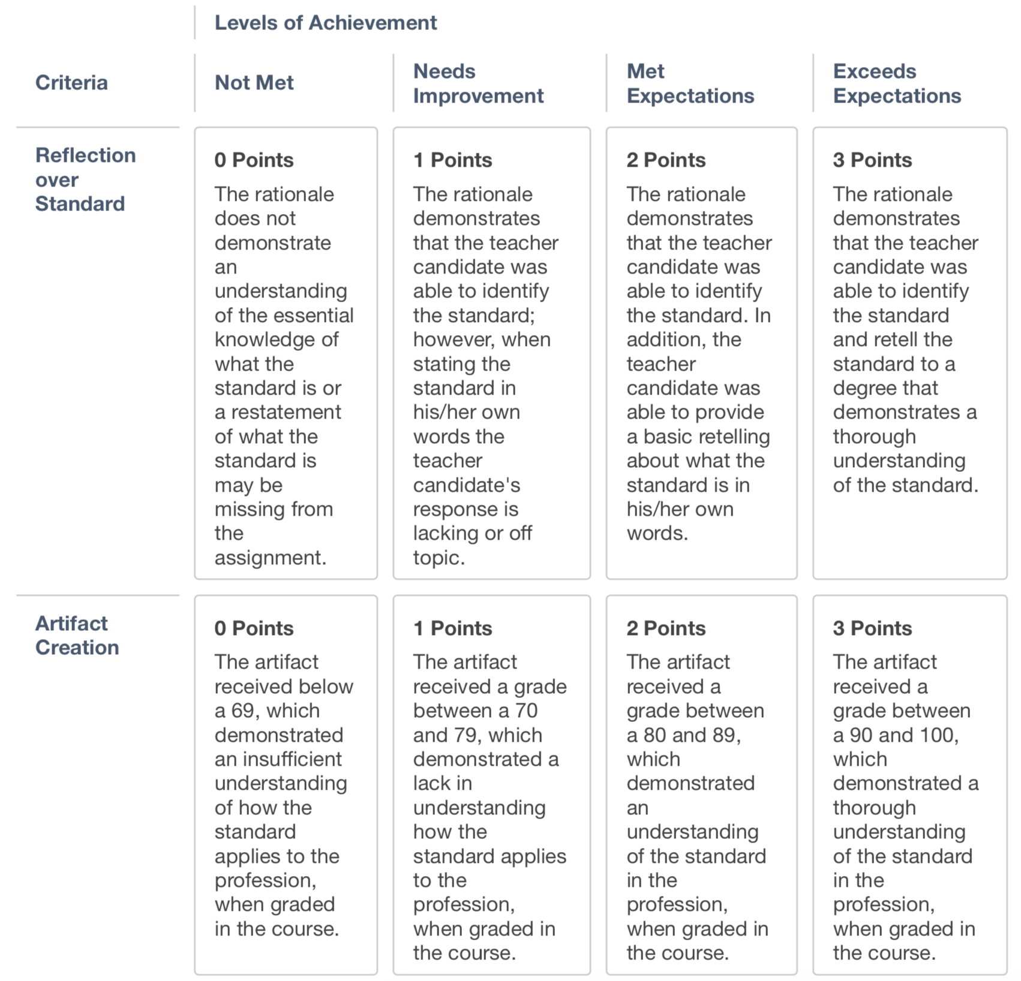

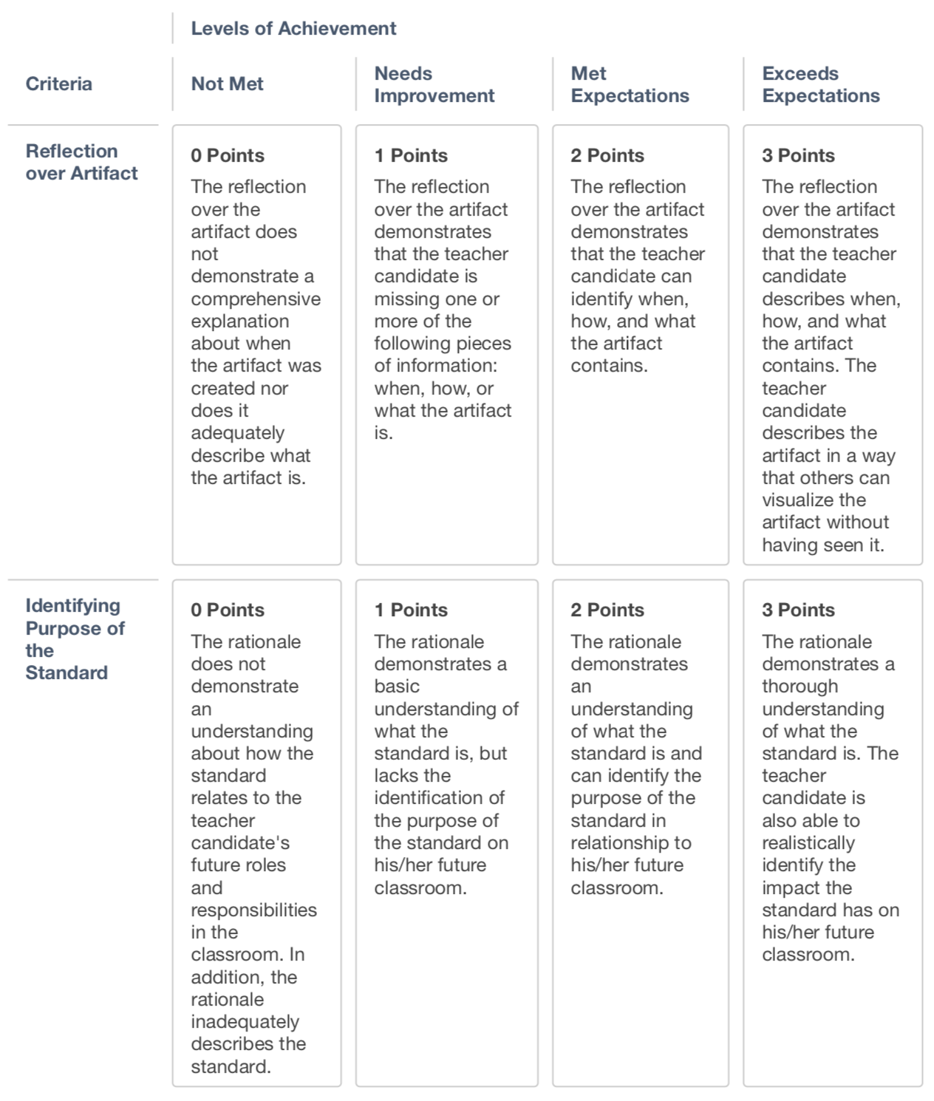

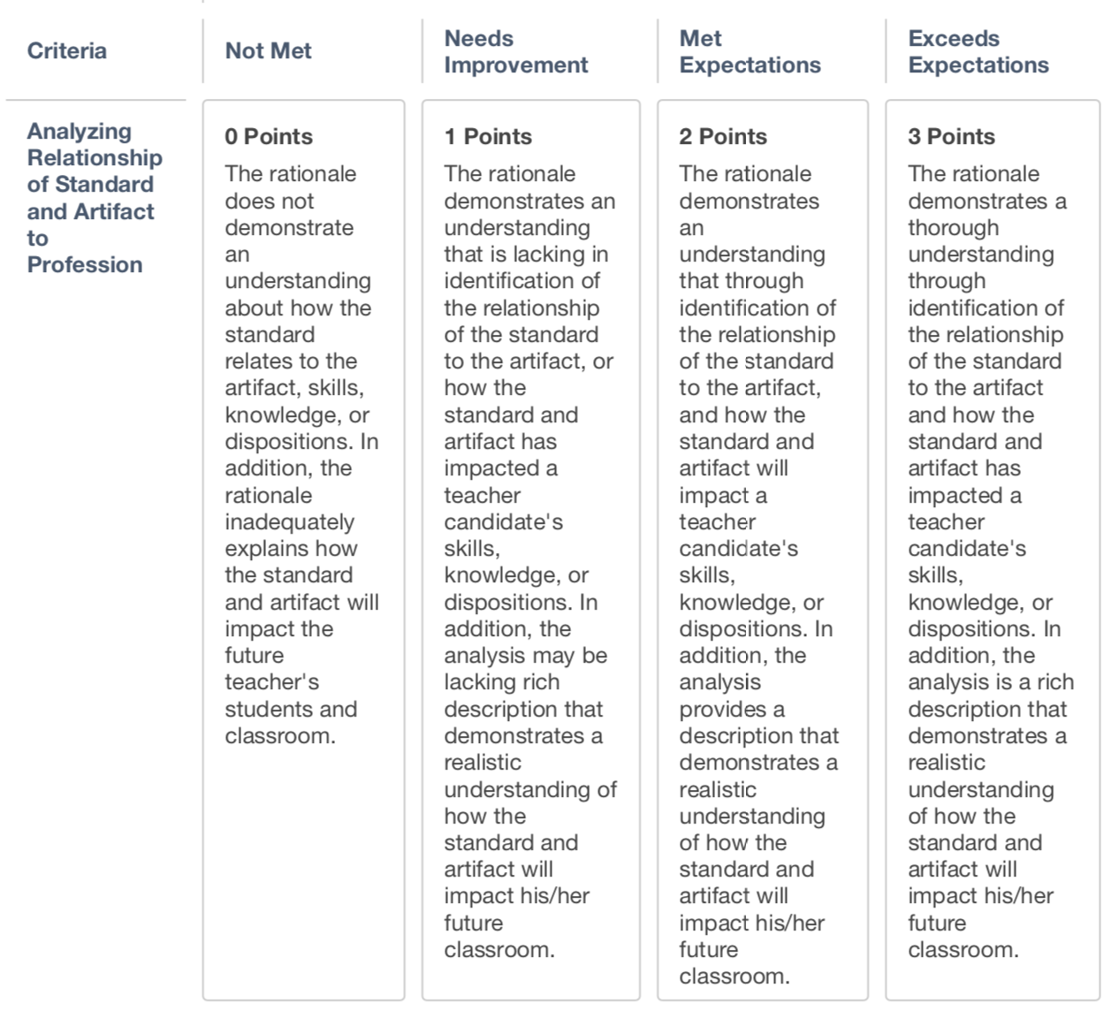

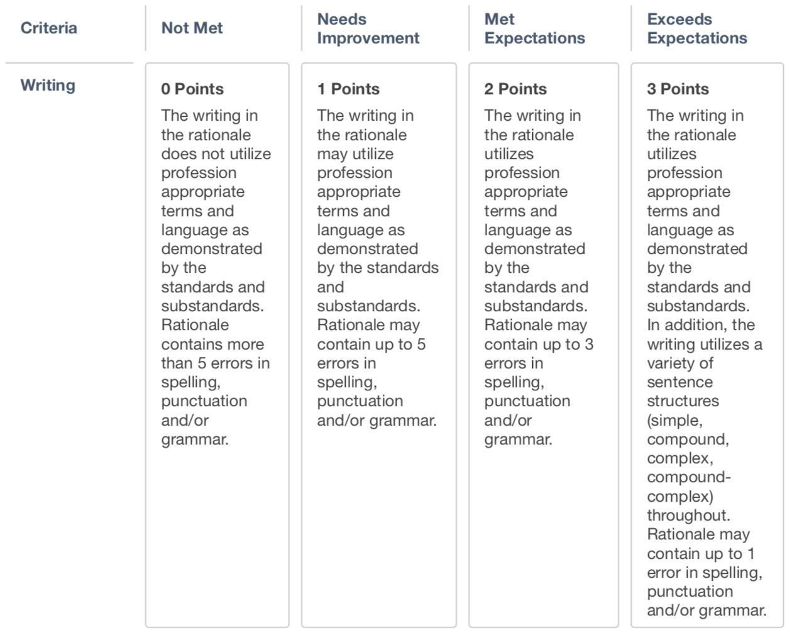

Portfolio Block Golden Ticket Rubric- Block I
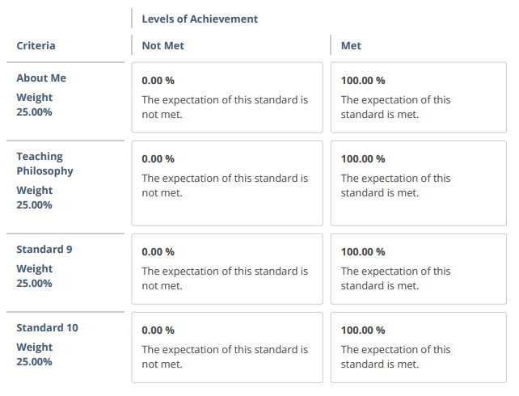

Portfolio Block Golden Ticket Rubric- Block II

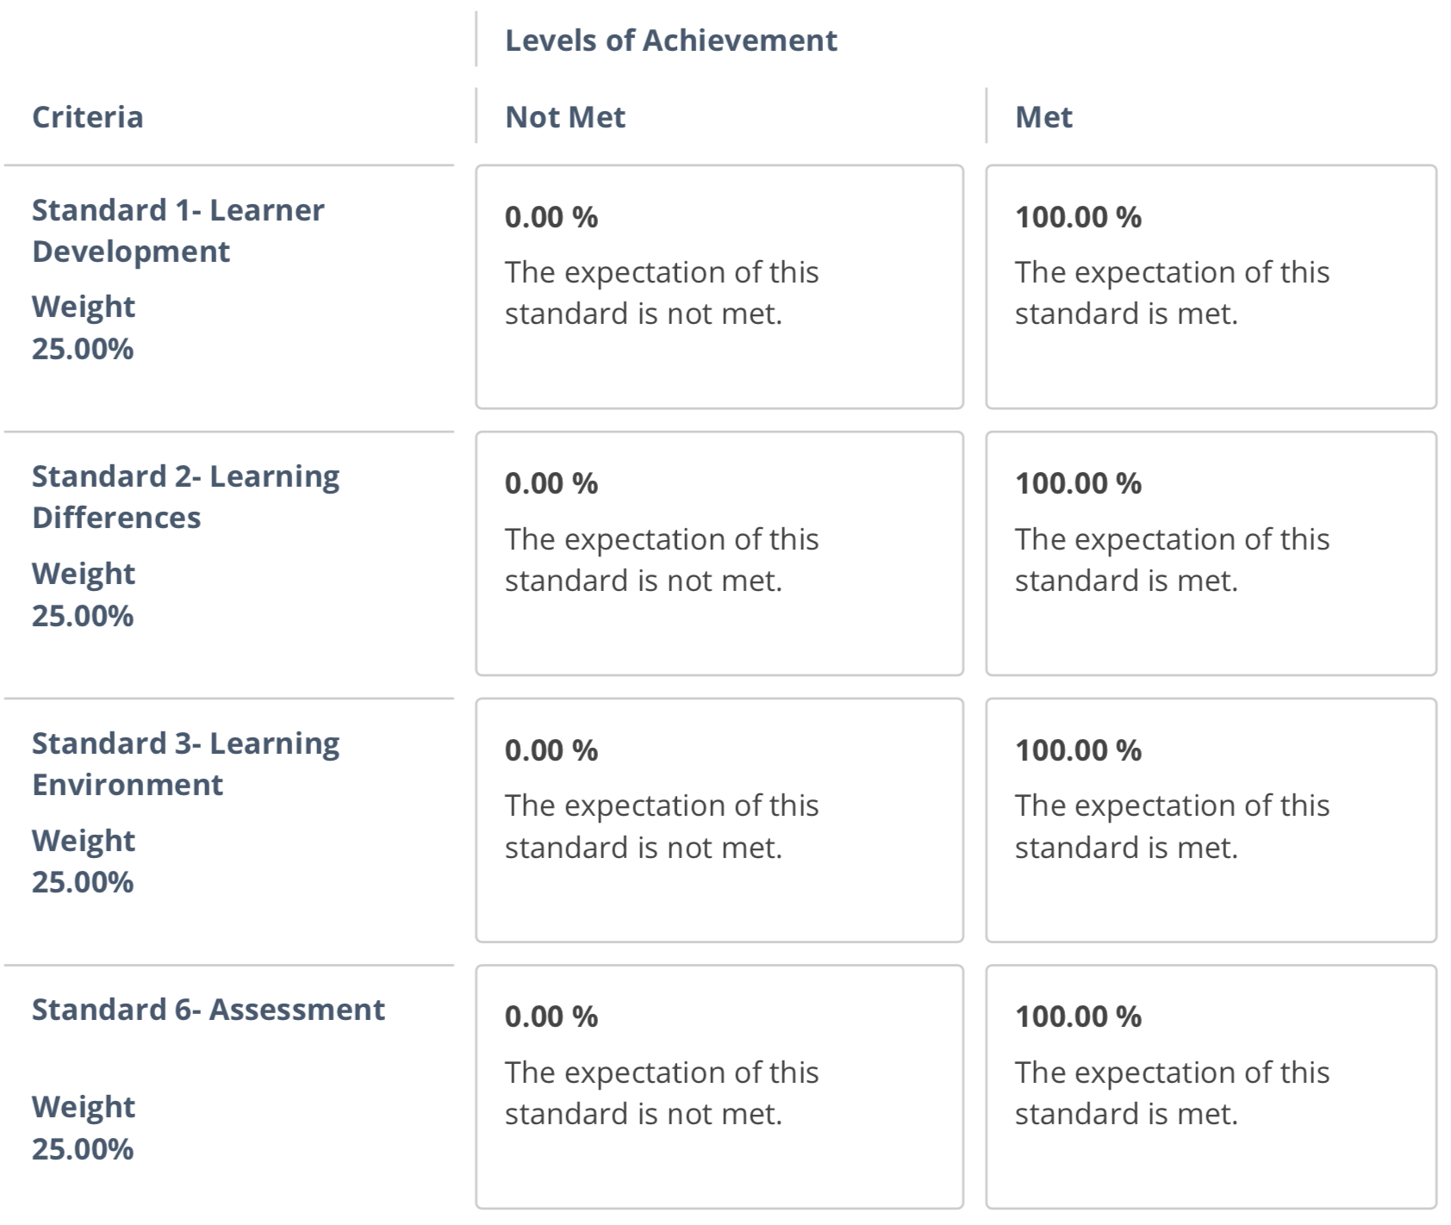

Portfolio Block Golden Ticket Rubric- Block III

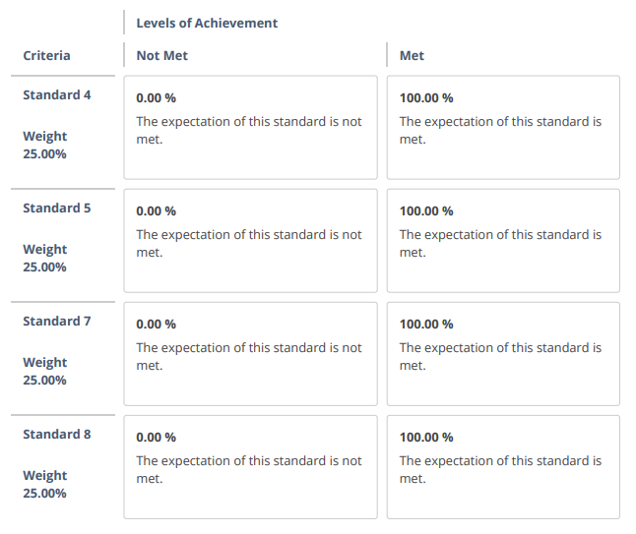

Setting Up the Blackboard Portfolio
- Step 1: Login to Blackboard
- Step 2: Click on “Portfolios” found under the “Tools” area
Note: EDUC 2631 will also have another option for setting up the portfolio.
- Step 3: Click on “Create Portfolio”
- Step 4: Label your Portfolio: “Your Last Name- Undergraduate Teacher Education Portfolio”
- Step 5: Click on “Select Portfolio Template”
- Step 6: Select “CEP- Undergraduate- Teacher Education Program Portfolio”

Customizing
Once the portfolio is created, students can customize their portfolio by clicking on the “Preview and Customize” option in the top right corner. Customization includes set up of portfolio and color.

Submitting Portfolio Assignments
When working in a Blackboard Portfolio, consider it as a work space. This means that anything that is in the portfolio workspace is not viewable by others until the owner of the workspace provides others with a snapshot of the workspace.

To submit assignments, most students will submit the assignment as a normal Blackboard assignment in his/her Blackboard course. Students will submit the artifact and the rationale at one time. The instructor will use the CEP- Undergraduate Teacher Education Portfolio Rubric to assess the assignment.

Students must make an 80% on this assignment, before they can upload the artifact and copy/paste the rationale in their portfolio. Students can continue to resubmit after changes are made until he/she makes an 80% or higher.

Once an 80% or higher is scores on the portfolio assignment, student upload the artifact and copy/paste the rationale in their portfolio. To submit the portfolio by Block at the end of each Professional Education Block, students will complete the portfolio requirements following the Golden Ticket guidelines. Once the portfolio section is complete, the student will go to the course where the Block Portfolio is to be submitted and “Select Portfolio” to submit a snapshot of their portfolio. If students go back and make changes, they will have to resubmit the portfolio in order for those changes to be viewable by the instructor.
- Block I: EDUC 2012, Diversity in American Education
- Block II: EDPSY 3513, Educational Psychology
- Block III: EDUC 4212, Strategies of Effective Teaching
- Block IV: EDUC 4262, Seminar I

Feedback for Portfolio Assignments
Feedback for portfolio assignments can be viewed through the Blackboard Grade Center. Other than the grade on the assignment, students will also see feedback on the assignment and/or through the rubric attached to the assignment.

Download a Portfolio
In order to view the portfolio after a student’s time at ECU, he/she will want to download the portfolio as a PDF. To download the portfolio, go to the Portfolios homepage, then click on “More”. Under “More”, select “Download”.

Tiger PRIDE Notes

- What program will you use to create your Portfolio? The e-Portfolio is created using Blackboard. All ECU students have access to the Portfolios area of Blackboard.
- When submitting a Portfolio assignment, what steps must I complete? First, students must complete the artifact. If the artifact is an InTASC Standard artifact, you will also have to complete a rationale. Once the artifact and/or rationale is complete, you submit the artifact and rationale to the instructor. Once you have received 80% or greater on the submission, then you can upload the artifact and/or rationale to the portfolio. Once all items for the Block are loaded and ready to be submitted, you submit the portfolio to the instructor by using the “Select Portfolio” option in a Blackboard assignment.
- Does the Portfolio have to be completed? All components of the Blackboard Portfolio must be completed before a student can move on to the next Block of instruction.

Appendix
Item A Professional Education Block Courses
Item B PPAT & InTASC Standards Alignment
Item C Teacher Education Interview Evaluation
Item D Candidate Field Experience Plan Sheet
Item E Disposition Rubric, Evaluation, and Concern
Item F Mentor Teacher Information
Item G Field Experience I-III - Letter to Administrator
Item H Field Experience I Evaluation
Item I Field Experience II Evaluation
Item J Field Experience III Evaluation
Item K Student Teaching - Letter to Administrator
Item L Student Teaching Evaluation

Item A: Professional Education Block Courses

Below is a list of the sequence of Professional Education Block Courses taken at ECU. Each course must be taken and a teacher candidate must receive a C in the course or better to progress through the courses. This sequence was approved by the Oklahoma Regents July 2017 and implemented Fall 2017 for students entering Block I.

Teacher Education Courses (5 Hours)
PSYCH 3463 Child and Adolescent Psychology
EDUC 2402 Survey of Exceptional Child

BLOCK I - Sophomore Year (5 Hours)
EDUC 2012 Diversity in American Education
EDUC 2402 Survey of Exceptional Child (If not taken earlier)
EDUC 2631 Foundations of Education Technology
EDUC 2211 Field Experience 1

BLOCK II – Junior Year (6 Hours)
EDPSY 3513 Educational Psychology
EDUC 3001 Field Experience II

BLOCK III – First Semester Senior Year (4 Hours)
EDUC 4043 Strategies for Effective Teaching
EDUC 4632 Strategies for Integrating Educational Technology
EDUC 4611 Field Experience III

BLOCK IV – Last Semester Senior Year (12 Hours)
EDUC 4262 Student Teaching Seminar I
EDUC 4282 Student Teaching Seminar II
EDUC 4954 Supervised Student Teaching Elementary Schools*
EDUC 4964 Supervised Student Teaching Grades PK-12*
EDUC 4974 Supervised Student Teaching Secondary Schools*
*Depends on a student’s program of study; enrolled in twice

Item B: PPAT and InTASC Alignment
InTASC STANDARD | BLOCK | PPAT® TASK ALIGNMENT | PERFORMANCE INDICATOR
Standard #1: Learner Development  The teacher understands how learners grow and develop, recognizing that patterns of learning and development vary individually within and across the cognitive, linguistic, social, emotional, and physical areas, and designs and implements developmentally appropriate and challenging learning experiences. | II | 2, 3, 4 | Performance Indicator 1(a): The teacher regularly assesses individual and group performance in order to design and modify instruction to meet learners’ needs in each area of development (cognitive, linguistic, social, emotional, and physical) and scaffolds the next level of development.
 |  | 1, 3, 4 | Performance Indicator 1(b): The teacher creates developmentally appropriate instruction that takes into account individual learners’ strengths, interests, and needs, and that enables each learner to advance and accelerate his/her learning.
 |  | 1 | Performance Indicator 1(c): The teacher collaborates with families, communities, colleagues, and other professionals to promote learner growth and development.
Standard #2: Learning Differences  The teacher uses understanding of individual differences and diverse cultures and communities to ensure inclusive learning environments that enable each learner to meet high standards. | II | 1, 3, 4 | Performance Indicator 2(a): PPAT® ® Candidate and Educator Handbook 6 The teacher designs, adapts, and delivers instruction to address each student’s diverse learning strengths and needs and creates opportunities for students to demonstrate their learning in different ways.
 |  | 2, 3, 4 | Performance Indicator 2(b): The teacher makes appropriate and timely provisions (e.g., pacing for individual rates of growth, task demands, communication, assessment, and response modes) for individual students with particular learning differences or needs.
 |  | 1, 3, 4 | Performance Indicator 2(c): The teacher designs instruction to build on learners’ prior knowledge and experiences, allowing learners to accelerate as they demonstrate their understandings.
 |  | 1 | Performance Indicator 2(d): The teacher brings multiple perspectives to the discussion of content, including attention to learners’ personal, family, and community experiences and cultural norms.
 |  |  | Performance Indicator 2(e): The teacher incorporates tools of language development into planning and instruction, including strategies for making content accessible to English-language learners and for evaluating and supporting their development of English proficiency.
 |  | 1, 2, 3 | Performance Indicator 2(f): The teacher accesses resources, supports, and specialized assistance and services to meet particular learning differences or needs.

Standard #3: Learning Environments  The teacher works with others to create environments that support individual and collaborative learning, and that encourage positive social interaction, active engagement in learning, and self-motivation. | II | 1 | Performance Indicator 3(a): The teacher collaborates with learners, families, and colleagues to build a safe, positive learning climate of openness, mutual respect, support, and inquiry.
 |  |  | Performance Indicator 3(b): The teacher develops learning experiences that engage learners in collaborative and self-directed learning and that extend learner interaction with ideas and people locally and globally.
 |  | 1 | Performance Indicator 3(c): The teacher collaborates with learners and colleagues to develop shared values and expectations for respectful interactions, rigorous academic discussions, and individual and group responsibility for quality work.
 |  | 1, 4 | Performance Indicator 3(d): The teacher manages the learning environment to actively and equitably engage learners by organizing, allocating, and coordinating the resources of time, space, and learners’ attention.
 |  | 3 | Performance Indicator 3(e): PPAT® ® Candidate and Educator Handbook 7 The teacher uses a variety of methods to engage learners in evaluating the learning environment, and collaborates with learners to make appropriate adjustments.
 |  | 1, 4 | Performance Indicator 3(f): The teacher communicates verbally and nonverbally in ways that demonstrate respect for and responsiveness to the cultural backgrounds and differing perspectives learners bring to the learning environment.
 |  |  | Performance Indicator 3(g): The teacher promotes responsible learner use of interactive technologies to extend the possibilities for learning locally and globally.
 |  |  | Performance Indicator 3(h): The teacher intentionally builds learner capacity to collaborate in face-to-face and virtual environments through applying effective interpersonal communication skills.
Standard #4: Content Knowledge  The teacher understands the central concepts, tools of inquiry, and structures of the discipline(s) he or she teaches and creates learning experiences that make these aspects of the discipline accessible and meaningful for learners to assure mastery of the content. | III |  | Performance Indicator 4(a): The teacher effectively uses multiple representations and explanations that capture key ideas in the discipline, guide learners through learning progressions, and promote each learner’s achievement of content standards.
 |  |  | Performance Indicator 4(b): The teacher engages students in learning experiences in the discipline(s) that encourage learners to understand, question, and analyze ideas from diverse perspectives so that they master the content.
 |  | 4 | Performance Indicator 4(c): The teacher engages learners in applying methods of inquiry and standards of evidence used in the discipline.
 |  | 1, 4 | Performance Indicator 4(d): The teacher stimulates learner reflection on prior content knowledge, links new concepts to familiar concepts, and makes connections to learners’ experiences.
 |  | 3 | Performance Indicator 4(e): The teacher recognizes learner misconceptions in a discipline that interfere with learning, and creates experiences to build accurate conceptual understanding.
 |  | 3, 4 | Performance Indicator 4(f): The teacher evaluates and modifies instructional resources and curriculum materials for their comprehensiveness, accuracy for representing particular concepts in the discipline, and appropriateness for his/ her learners
 |  | 1, 3 | Performance Indicator 4(g): The teacher uses supplementary resources and technologies effectively to ensure accessibility and relevance for all learners.
 |  | 4 | Performance Indicator 4(h): The teacher creates opportunities for students to learn, practice, and master academic language in the content.
 |  |  | Performance Indicator 4(i): PPAT® ® Candidate and Educator Handbook 8 The teacher accesses school and/or district-based resources to evaluate the learner’s content knowledge in their primary language.
Standard #5: Application of Content  The teacher understands how to connect concepts and use differing perspectives to engage learners in critical thinking, creativity, and collaborative problem solving related to authentic local and global issues. | III |  | Performance Indicator 5(a): The teacher develops and implements projects that guide learners in analyzing the complexities of an issue or question using perspectives from varied disciplines and cross-disciplinary skills (e.g., a water quality study that draws upon biology and chemistry to look at factual information and social studies to examine policy implications).
 |  |  | Performance Indicator 5(b): The teacher engages learners in applying content knowledge to real world problems through the lens of interdisciplinary themes (e.g., financial literacy, environmental literacy).
 |  |  | Performance Indicator 5(c): The teacher facilitates learners’ use of current tools and resources to maximize content learning in varied contexts.
 |  |  | Performance Indicator 5(d): The teacher engages learners in questioning and challenging assumptions and approaches in order to foster innovation and problem solving in local and global contexts.
 |  |  | Performance Indicator 5(e): The teacher develops learners’ communication skills in disciplinary and interdisciplinary contexts by creating meaningful opportunities to employ a variety of forms of communication that address varied audiences and purposes.
 |  |  | Performance Indicator 5(f): The teacher engages learners in generating and evaluating new ideas and novel approaches, seeking inventive solutions to problems, and developing original work.
 |  |  | Performance Indicator 5(g): The teacher facilitates learners’ ability to develop diverse social and cultural perspectives that expand their understanding of local and global issues and create novel approaches to solving problems.
 |  | 4 | Performance Indicator 5(h): The teacher develops and implements supports for learners’ literacy development across content areas.
Standard #6: Assessment  The teacher understands and uses multiple methods of assessment to engage learners in their own growth, to monitor learner progress, and to guide the teacher’s and learner’s decision making. | II | 3, 4 | Performance Indicator 6(a): The teacher balances the use of formative and summative assessment as appropriate to support, verify, and document learning.
 |  | 2, 4 | Performance Indicator 6(b): The teacher designs assessments that match learning objectives with assessment methods and minimizes sources of bias that can distort assessment results.
 |  | 2, 3, 4 | Performance Indicator 6(c): The teacher works independently and collaboratively to examine test and other performance data to understand each learner’s progress and to guide planning.
 |  | 2, 3 | Performance Indicator 6(d): The teacher engages learners in understanding and identifying quality work and provides them with effective descriptive feedback to guide their progress toward that work.
 |  |  | Performance Indicator 6(e): The teacher engages learners in multiple ways of demonstrating knowledge and skill as part of the assessment process.
 |  |  | Performance Indicator 6(f): The teacher models and structures processes that guide learners in examining their own thinking and learning as well as the performance of others.
 |  | 1, 2, 3, 4 | Performance Indicator 6(g): The teacher effectively uses multiple and appropriate types of assessment data to identify each student’s learning needs and to develop differentiated learning experiences.
 |  | 2 | Performance Indicator 6(h): The teacher prepares all learners for the demands of particular assessment formats and makes appropriate accommodations in assessments or testing conditions, especially for learners with disabilities and language-learning needs.
 |  |  | Performance Indicator 6(i): The teacher continually seeks appropriate ways to employ technology to support assessment practice both to engage learners more fully and to assess and address learner needs,
Standard #7: Planning for Instruction  The teacher plans instruction that supports every student in meeting rigorous learning goals by drawing upon knowledge of content areas, curriculum, cross-disciplinary skills, and pedagogy, as well as knowledge of learners and the community context. | III | 1, 3, 4 | Performance Indicator 7(a): The teacher individually and collaboratively selects and creates learning experiences that are appropriate for curriculum goals and content standards and are relevant to learners.
 |  | 1, 3, 4 | Performance Indicator 7(b): The teacher plans how to achieve each student’s learning goals by choosing appropriate strategies, accommodations, resources, and materials to differentiate instruction for individuals and groups of learners.
 |  | 3, 4 | Performance Indicator 7(c): The teacher develops appropriate sequencing of learning experiences and provides multiple ways for learners to demonstrate knowledge and skills.
 |  | 1, 2, 3, 4 | Performance Indicator 7(d): The teacher plans for instruction based on formative and summative assessment data, learners’ prior knowledge, and learners’ interests.
 |  | 1 | Performance Indicator 7(e): The teacher plans collaboratively with professionals who each have specialized expertise (e.g., special educators, related service providers, language-learning specialists, librarians, and media specialists) to design and jointly deliver appropriate learning experiences that meet unique learning needs.
 |  | 3, 4 | Performance Indicator 7(f): The teacher evaluates his or her plans in relation to short- and long-range goals and systematically adjusts plans to meet each student’s learning needs and to enhance learning
Standard #8: Instructional Strategies  The teacher understands and uses a variety of instructional strategies to encourage learners to develop deep understanding in and across content areas and to build skill at applying knowledge in meaningful ways. | III | 1, 3, 4 | Performance Indicator 8(a): The teacher uses appropriate strategies and resources to adapt instruction to the needs of individuals and of groups of learners.
 |  | 2, 3, 4 | Performance Indicator 8(b): The teacher continuously monitors student learning, engages learners in assessing their own progress, and adjusts instruction in response to students’ learning needs.
 |  | 1 | Performance Indicator 8(c): The teacher collaborates with learners to design and implement relevant learning experiences, to identify their strengths, and to access family and community resources to develop learners’ areas of interest.
 |  | 4 | Performance Indicator 8(d): The teacher varies his/her role in the instructional process (e.g., instructor, facilitator, coach, and audience) in relation to the content and purposes of instruction and the needs of learners.
 |  | 2, 3, 4 | Performance Indicator 8(e): The teacher provides multiple models and representations of concepts and skills with opportunities for learners to demonstrate their knowledge through a variety of products and performances.
 |  | 4 | Performance Indicator 8(f): The teacher engages all learners in developing higher-order questioning skills and metacognitive processes.
 |  | 2, 3, 4 | Performance Indicator 8(g): The teacher engages learners in using a range of learning skills and technology tools to access, interpret, evaluate, and apply information.
 |  | 4 | Performance Indicator 8(h): The teacher uses a variety of instructional strategies to support and expand learners’ communication through speaking, listening, reading, writing, and other modes.
 |  | 4 | Performance Indicator 8(i): The teacher asks questions to stimulate discussion that serves different purposes (e.g., probing for learner understanding, helping learners articulate their ideas and thinking processes, stimulating curiosity, and helping learners to question).
Standard #9: Professional Learning and Ethical Practice  The teacher engages in ongoing professional learning and uses evidence to continually evaluate his/her practice, particularly the effects of his/her choices and actions on others (learners, families, other professionals, and the community), and adapts practice to meet the needs of each learner. | I | 2, 3, 4 | Performance Indicator 9(a): The teacher engages in ongoing learning opportunities to develop knowledge and skills in order to provide all learners with engaging curriculum and learning experiences based on local and state standards.
 |  | 1, 4 | Performance Indicator 9(b): The teacher engages in meaningful and appropriate professional learning experiences aligned with his/her own needs and the needs of the learners, school, and system.
 |  | 1, 2, 3, 4 | Performance Indicator 9(c): Independently and in collaboration with colleagues, the teacher uses a variety of data (e.g., systematic observation, information about learners, research) to evaluate the outcomes of teaching and learning and to adapt planning and practice.
 |  | 1, 4 | Performance Indicator 9(d): The teacher actively seeks professional, community, and technological resources, within and outside the school, as supports for analysis, reflection, and problem-solving.
 |  | 1, 2 | Performance Indicator 9(e): The teacher reflects on his/her personal biases and accesses resources to deepen his/her own understanding of cultural, ethnic, gender, and learning differences to build stronger relationships and create more relevant learning experiences.
 |  | 1 | Performance Indicator 9(f): The teacher advocates, models, and teaches safe, legal, and ethical use of information and technology including appropriate documentation of sources and respect for others in the use of social media.

Standard #10: Leadership and Collaboration  The teacher seeks appropriate leadership roles and opportunities to take responsibility for student learning, to collaborate with learners, families, colleagues, other school professionals, and community members to ensure learner growth, and to advance the profession | I |  | Performance Indicator 10(a): The teacher takes an active role on the instructional team, giving and receiving feedback on practice, examining learner work, analyzing data from multiple sources, and sharing responsibility for decision making and accountability for each student’s learning.
 |  | 1 | Performance Indicator 10(b): The teacher works with other school professionals to plan and jointly facilitate learning on how to meet diverse needs of learners.
 |  |  | Performance Indicator 10(c): The teacher engages collaboratively in the school wide effort to build a shared vision and supportive culture, identify common goals, and monitor and evaluate progress toward those goals.
 |  | 1 | Performance Indicator 10(d): The teacher works collaboratively with learners and their families to establish mutual expectations and ongoing communication to support learner development and achievement.
 |  | 1 | Performance Indicator 10(e): Working with school colleagues, the teacher builds ongoing connections with community resources to enhance student learning and well-being.
 |  |  | Performance Indicator 10(f): The teacher engages in professional learning, contributes to the knowledge and skill of others, and works collaboratively to advance professional practice.
 |  |  | Performance Indicator 10(g): The teacher uses technological tools and a variety of communication strategies to build local and global learning communities that engage learners, families, and colleagues.
 |  |  | Performance Indicator 10(h): The teacher uses and generates meaningful research on education issues and policies.
 |  |  | Performance Indicator 10(i): The teacher seeks appropriate opportunities to model effective practice for colleagues, to lead professional learning activities, and to serve in other leadership roles.
 |  | 1, 2 | Performance Indicator 10(j): The teacher advocates to meet the needs of learners, to strengthen the learning environment, and to enact system change.
 |  |  | Performance Indicator 10(k): The teacher takes on leadership roles at the school, district, state, and/or national level and advocates for learners, the school, the community, and the profession.

Item C: Teacher Education Interview
This assessment is completed during application to Teacher Education by two faculty members. The assessment was modified and implemented in the Spring 2017.

PDF of Assessment
https://drive.google.com/file/d/0B0D-tzaN2yrHc1kyQ3J5LXlNNTQ/view

Link to Complete Assessment
https://docs.google.com/forms/d/1lJBxyfUFtDjqm7kWY0akojaY-O3IL7VCsIm4NpHtTUA/viewform?edit_requested=true

Data Collected
https://docs.google.com/document/d/1ym0XxAHCsHD-u9LJwFCCqCKBrWCKwRrucyhtVUechRQ/edit

Item D: Field Experience Plan Sheet

East Central University
Department of Education
Field Experience Plan Sheet
During a candidate’s time at East Central University, he or she will be asked to make 5 Field Experience Proposals through Chalk and Wire. As a part of the Field Experience expectations, a candidate must have experience in at least 3 different school districts. To help plan out proposals, please complete the following form.
Field Experience | Proposal
BLOCK I:  Field Experience I  Same school district- 1 elementary, 1 high school | Elementary: | High School:
BLOCK II:
Field Experience II
Different school district than Block I.

BLOCK III:
Field Experience III
Different school district than Block I and Block II.

BLOCK IV:
Field Experience IV/
Student Teaching
This district/school may be the same as Block I, II, or III- it is recommended that this placement be the same as Block III.

*These proposals must be made to the Field Experience/Student Teaching Coordinator.

Item E: Disposition Rubric, Evaluation, and Concern
Disposition Rubric and Evaluation
This assessment is completed during the Foundations of Education and during the Student Teaching semester by Cooperating Teachers, Student Teacher, and University Supervisor. Assessment modified Spring 2017 and modified assessment used Fall 2017 embedded in Student Teaching Evaluation.

Rubric of Expectations
https://drive.google.com/file/d/0B0D-tzaN2yrHVDJpejhkN180R28/view

PDF of Assessment
https://drive.google.com/file/d/0B0D-tzaN2yrHUjhZNXdXdzZGRmc/view

Link to Complete Assessment
https://docs.google.com/forms/d/e/1FAIpQLSevEm1U6Th2ncq2-p-iZMixmCqZRXVKjx7oaDYn8bhmfY6dLA/viewform

Disposition Concern
This assessment is completed at anytime during a student’s enrollment at ECU by anyone who has a concern about a student majoring in Education. Assessment modified Spring 2017 and modified assessment used in Spring 2017.

PDF of Assessment
https://drive.google.com/file/d/0B0D-tzaN2yrHekRMdXhVQXZfN3M/view

Link to Complete Assessment
https://docs.google.com/forms/d/e/1FAIpQLSdq2MYrQoQg3W6Y97-AEl4jo8vfNJMzX5PfxOrSds06CqoSYQ/viewform

Item F: Field Experience Expectations

East Central University
Department of Education
Field Experience Expectations
Thank you so much for your interest in partner with East Central University’s Department of Education. As part of our continuing effort to partner with you, here are a few things we need to bring to your attention.
Standards of Professionalism During Field Experiences
During the in-school field experiences, candidates are expected to follow the principles, standards, and rules regarding proficiencies, dispositions/attitudes, and professional practice described in the ECU’s Department of Education Disposition Rubric, https://docs.google.com/document/d/1QDVO3MzgeVKz6KaoX43xX5_yONPpzH8IqtoskYrGdxo/edit?usp=sharing. Students should behave professionally at all times. Candidates need to strive to make a good impression and act in a professional manner at all times. Candidates should:
- Arrive on time
- Dress professionally and attend to personal hygiene
- Wear any district required identification in plain sight at all times
- Keep field experience appointments- if an emergency arises and plans must be adjusted, the candidate should notify the school and teacher immediately
- Track all field experience hours on required times sheets and Chalk and Wire logs
- Use professional language in and out of the classroom with everyone (no profanity or overly casual language) with students and adults alike
- Demonstrate attentiveness and eagerness to learn
- Display a willingness to work with students from different cultures, different socioeconomic levels, and different learning abilities
- Be respectful to peers, families, teachers, staff, and administrators
- Be committed to meeting the educational needs of all students in a caring, nondiscriminatory, and equitable manner
- Demonstrate a belief that all students can learn
- Display persistence in the face of difficulty, stress, or adverse conditions
- Display a positive attitude toward teaching and learning
- No cell phone use while in field placements
- Spend all of your field experience time engaged in appropriate professional/educational activities
- Sign in and out in the office daily
- Thank your cooperating teacher and the office personnel each time you visit the school

Field Experiences at ECU
At ECU teacher candidates progress through their program at varying paces, but yet structured experiences. The following diagram outlines the four different Professional Education Blocks at ECU and the Field Experience hours they complete as a part of their coursework.

*For teacher candidates beginning their Teacher Education Program in the Fall of 2017 or later.
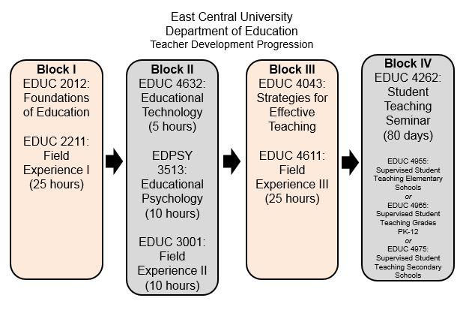

*Teacher candidates who entered the Teacher Education Program before Fall 2017.

Evaluations of Field Experiences
During Blocks I, II, and III cooperating teachers will be emailed a link to an evaluation using Google Sheets toward the end of the semester.

During Block IV, Student Teaching, evaluations will be email to cooperating teachers, student teachers, and university supervisors halfway through the semester as well as at the end of the semester. The following evaluations must be completed: 2 evaluations over a candidate’s disposition and 2 evaluations over the candidates teaching skills (midterm and final).

Issues During Field Experiences
If at any time, a cooperating teacher becomes concerned with an ECU candidate in the field, please fill out a Dispositional Concern form https://goo.gl/forms/Yb1U2f8o2iFJ6UYB2, or notify the Coordinator of Field Experiences & Student Teaching.

Item G: Field Experience I-III - Letter to Administrators

EAST CENTRAL UNIVERSITY
Letter to Administrators
Placement of
Field Experience for Block I-III Students
Dear Principals/School Contacts,
I am writing to share the attached Teacher Candidate (TC) Placement Request for East Central University (ECU) students who wish to complete their Field Experience for Block I, Block II, or Block III in your school district or school site.
- Mentor Teacher (MT) Qualifications:
      - The MT is certified and teaches in the teacher candidate’s teaching field or placement needs (Block I students must complete their Field Experience hours in an Early Childhood or Elementary placement and a Secondary placement).
      - The MT has a minimum of 1 year experience in the teaching profession.

- Mentor Teacher (MT) Responsibilities:
      - The MT will accept responsibility for guidance, communication and evaluation of the teacher candidate.
An evaluation is emailed to the MT at the conclusion of the semester or once the student completes his/her hours.
      - The MT will utilize their content knowledge to guide the teacher candidate in Block activities.
      - The MT will provide a positive, nurturing environment for the teacher candidate.
      - The MT will notify the Field Experience Coordinator immediately if teacher candidate issues arise.

- Placement Information:
      - For Block I placements:
        - Students complete 25 total hours in the Field- 12 hours in one placement and 13 hours in a second placement.
        - Students will collect general demographic information of the class (PPAT Task 1 exercise*); interview mentor teachers (PPAT Task 1 exercise*); and tutor or complete a small group lesson.
      - For Block II placements:
        - Students complete 25 total hours in the Field in the teacher candidate’s teaching field.
        - Students will collect general demographic information of the class (PPAT Task 1 exercise*); teach 2 mini-lessons and collect pre-/post-assessment data, or baseline data and assessment data (PPAT Task 2 exercise*); and tutor students.
      - For Block III placements:
- Students complete 25 total hours in the Field in one placement in the teacher candidate’s teaching field.
- Students will collect general demographic information of the class and information from students by completing a Student Interest Inventory (PPAT Task 1 exercise*); and teaching 1 lesson based on the needs collected in the Student Interest Inventory (PPAT Task 3 exercise*).
- Principals/Administrators only:
- To accept or not accept the teacher candidate in your district/building site,
CLICK HERE ---> Student Teacher Placement Confirmation Form
and complete the online form as soon as possible. Please refer to the candidate information found in the subject line of the email to complete this form.
- If you cannot provide a field placement for the teacher candidate, please check the “No” box and then the teacher candidate’s name and your district and submit as soon as possible.
- Note: Each teacher candidate has completed a background check through Castle Branch, https://www.castlebranch.com/, and been cleared before being approved to complete their clinical experience.
The ECU Department of Education sincerely appreciates the invaluable assistance you provide us by allowing our teacher candidates experiences in your district. If you have any questions or concerns about a particular placement, please contact me at your earliest convenience. This email is designed so that you may forward it to your potential mentor teachers for their review. However, I ask that only administrators/principals complete the online form for each teacher candidate request. Thank you again! We look forward to hearing from you very soon.

Respectfully,

Coordinator of Field Experiences

Item H: Field Experience I Evaluation
Completed during the Block I semester by Mentor Teachers. The assessment is automatically emailed to Mentor Teachers once the Field Log is completed by teacher candidates. Assessment modified Spring 2017 and modified assessment circulated Fall 2017.

PDF of Assessment
https://drive.google.com/file/d/0B0D-tzaN2yrHbWpRV3QxWTdTVkE/view

Item I: Field Experience II Evaluation
Completed during the Block II semester by Mentor Teachers. The assessment is automatically emailed to Mentor Teachers once the Field Log is completed by teacher candidates. Assessment modified Spring 2017 and modified assessment circulated Fall 2017.

PDF of Assessment
https://drive.google.com/file/d/0B0D-tzaN2yrHSVNDUEw1TlJPWkk/view

Item J: Field Experience III Evaluation
Completed during the Block III semester by Mentor Teachers. The assessment is automatically emailed to Mentor Teachers once the Field Log is completed by teacher candidates. Assessment modified Spring 2017 and modified assessment circulated Fall 2017.
PDF of Assessment
https://drive.google.com/file/d/0B0D-tzaN2yrHSXM5eF82NEhZdFU/view

Item K: Student Teaching - Letter to Administrators

EAST CENTRAL UNIVERSITY
Letter to Administrators
Placement of
Student Teachers

Dear Principals/School Contacts,
I am writing to share the attached Teacher Candidate Placement Request Link and Resume(s) for East Central University (ECU) student(s) who wish to be teacher candidates/student teachers in your school district or school site.
- Cooperating Teacher (CT) Qualifications:
      - The CT is certified and teaches in the teacher candidate’s teaching field.
      - The CT has a minimum of 3 years’ experience in the teaching profession.
      - The CT has taught at least 1 full year in the school district.

- Expectations of the Cooperating Teacher (CT):
      - The CT will accept responsibility for guidance, communication and evaluation of the teacher candidate.
      - The CT will utilize their content knowledge to guide the teacher candidate in daily teacher activities.
      - The CT will provide a positive, nurturing environment for the teacher candidate.
      - The CT will notify the Field Experience Coordinator immediately if teacher candidate issues arise.
      - The CT will attend the Cooperating Teacher Forum at East Central University (the date of dinner and collaboration event will be sent at a later time).
*The CT will receive a stipend for mentoring a teacher candidate.

- Placement Information:
      - For All Placements: Teacher candidates are required to have diverse clinical experiences; therefore, only two Block placements (Field Experience I, Field Experience II, Field Experience III, and Student Teaching) can occur at a single school/district. While teacher candidates are encouraged to complete Field Experience III at the same location as their Student Teaching, this is not always feasible.
      - For Elementary and Secondary placements:
        - It is the preference of the ECU Department of Education that these teacher candidates are placed with the same CT(s) for the entire 480-hour placement.
      - For PK-12 Placements for Art and Music majors, who are, in most cases, required to complete split placements, please note the following:
- A Split Placement is where the teacher candidate is assigned to an elementary site for 240 hours or more and a secondary site for no fewer than 180 hours. The order of split placements may be at the discretion of the school district.
      - For Early Childhood placements, split placements are required.
- For ECU Split Placements, the teacher candidate must be assigned to a Pre K-3rd grade placement for 240 hours or more and then a second placement where he/she must be assigned to a different Pre K-3rd grade classroom for no fewer than 180 hours at the same school. It is recommended that one placement be in Pre K or K and that the second placement be in 1st, 2nd, or 3rd grade. The order of split placements may be at the discretion of the school district.

- Principals/Administrators only:
- To accept or not accept the teacher candidate in your district/building site,
CLICK HERE ---> Student Teacher Placement Confirmation Form
and complete the online form as soon as possible. Please refer to the candidate information found in the subject line of the email to complete this form.
- If you cannot provide a placement for the teacher candidate, please check the “No” box and note the teacher candidate’s name and your district and submit as soon as possible.
- Note: Each teacher candidate has completed a background check through Castle Branch, https://www.castlebranch.com/, and been cleared before being approved to complete their student teaching/clinical experience.
The ECU Department of Education sincerely appreciates the invaluable assistance you provide us by allowing our teacher candidates experiences in your district. If you have any questions or concerns about a particular placement, please contact me at your earliest convenience. This email is designed so that you may forward it to your potential cooperating teachers for their review. However, I ask that only administrators/principals complete the online form for each teacher candidate request. Thank you again! We look forward to hearing from you very soon.

Respectfully,

Coordinator of Student Teaching

Item L: Student Teacher Evaluation
This assessment is completed during the Student Teaching semester beginning Fall 2016 by Cooperating Teachers, Student Teachers, and University Supervisors. The evaluation was updated in the Spring of 2017 and implemented during the Fall of 2017. Cooperating Teachers, Student Teachers, and University Supervisors complete the assessment twice (midterm and final).

PDF of Assessment
https://drive.google.com/file/d/0B0D-tzaN2yrHMWxBVnZJQVRUdDA/view

Link to Complete Assessment
https://docs.google.com/forms/d/e/1FAIpQLSdosT5BwbHzTewTqROr5KU-od4vWjQvNLaI13OciWIgHhp9zg/viewform?usp=sf_link

Data Collected
https://docs.google.com/document/d/1T1jmoIOXGw1dOZHQQ1wxfpsQVaGw73kzuDWoQ-w5_vI/edit

